3.2.2
NUMBER OF WORKSHOPS/SEMINARS CONDUCTED ON RESEARCH METHODOLOGY, INTELLECTUAL PROPERTY RIGHTS (IPR) AND ENTREPRENEURSHIP

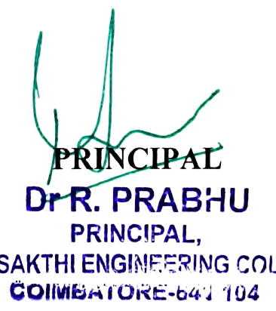

3.2.2:NUMBER OF WORKSHOPS/SEMINARS CONDUCTED ON RESEARCH METHODOLOGY, INTELLECTUAL PROPERTY RIGHTS (IPR) AND ENTREPRENEURSHIP

Year | Name of the workshop/ seminar | Number of Participants | Date From – To
2022 | Workshop on PCB Design | 40 | 20.12.23
2023 | Seminar on Enterpreunership | 42 | 10.03.23
2022 | Seminor on Motor control and Industrial component | 45 | 19.09.22
2023 | Workshop on Industrial Drives and Control | 44 | 14.02.23
2022 | Introduction to research methodolgy | 67 | 28.10.2022
2022 | ROLE OF ENTREPRENEUR IN SOCIETY | 58 | 16.12.2022
2023 | 3D Modelling and Sketchup | 44 | 11.02.2023
2022 | Recent Trend in Construction Industry Techniques | 67 | 25.09.2022
2022 | Project Management Tools and Techniques for Engineers | 58 | 29.10.2022
2022 | Methodology of Thesis Writing (III&IV year) | 24 | 08.07.2022
2022 | Building awareness on IPR (III&IV year) | 24 | 08.07.2022
2023 | Awareness on Current Research Themes (II&III year) | 52 | 27.04.2023
2022 | Workshop on Cloud Computing | 68 | 05.05.2022
2022 | Personality Development and Soft skills | 68 | 24.09.2022
2022 | Ethical Hacking and Cyber Security | 68 | 18.10.2022
2023 | Artificial Intelligence and Machine learning | 91 | 10.03.23
2023 | Internet of Things(IOT) | 91 | 28.04.2023
2023 | Unveiling new avenues next generation high performance computing | 91 | 19.05.2023

INTRODUCTION TO RESEARCH AND METHODOLOGY

OBJECTIVE OF THE PROGRAMME:
The systematic method consisting of enunciating the problem, formulating a hypothesis, collecting the facts and reaching certain conclusion either in the form of solutions towards the concerned problem or in certain generalizations for some theoretical formulations.
Research is the systematic efforts gathering, analysing and interpreting the problems confronted by humanity. It is a thinking process and scientific method of studying a problem and finding solution.
OUTCOME OF THE PROGRAMME:
To gain familiarity with a phenomenon or to achieve a new insights into it.
To portray accurately the characteristics of a particular individual situation or a group.
To test a hypothesis of a causal relationship between variables.

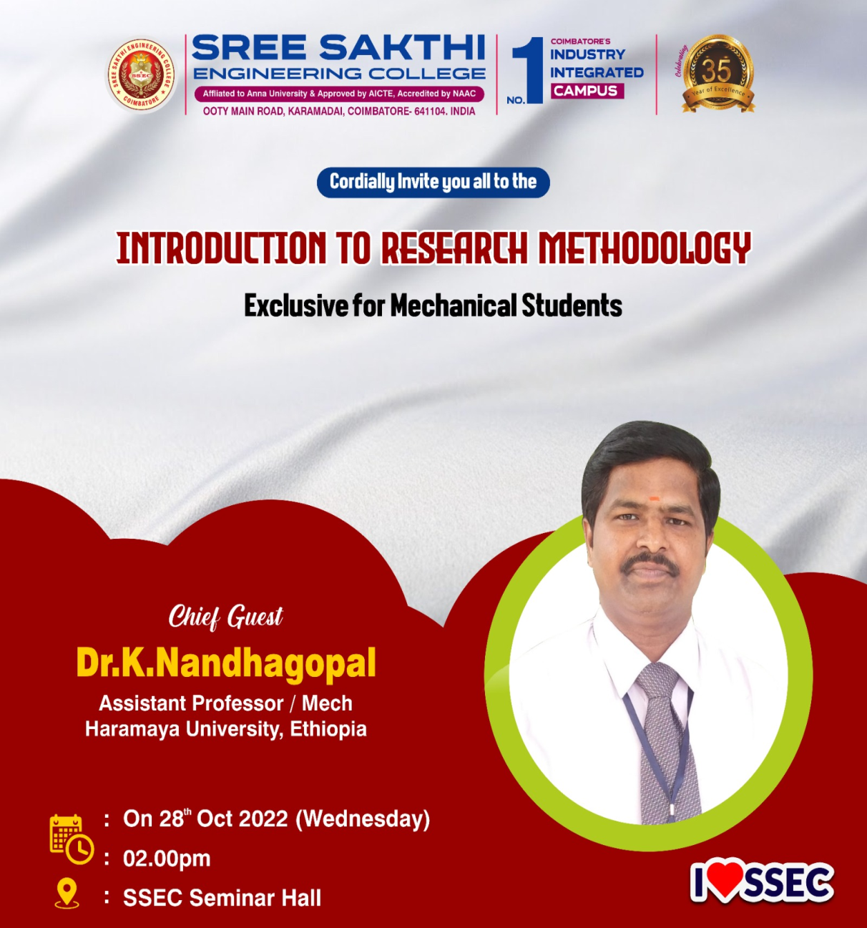

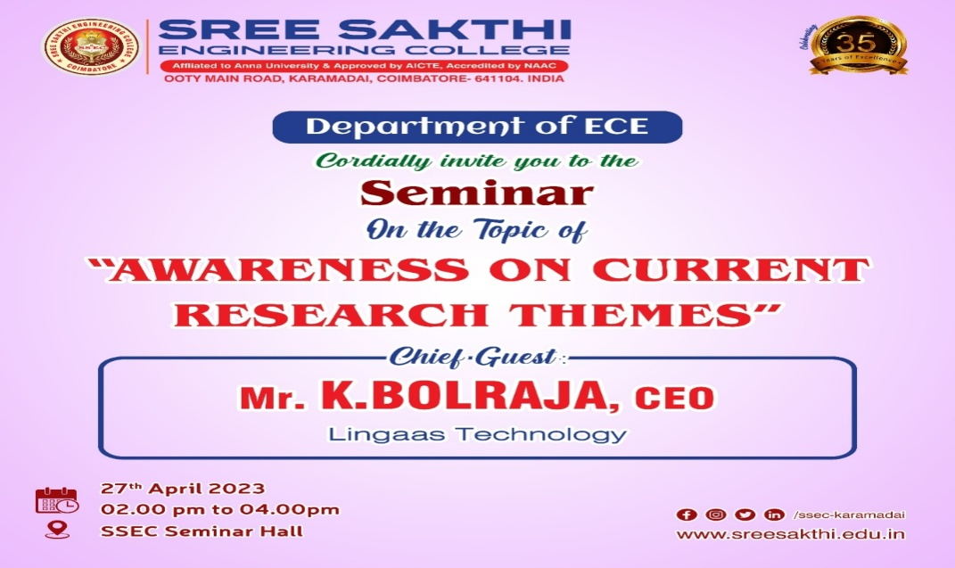

ROLE OF ENTERPRENUERSHIP IN SOCIETY
OBJECTIVE OF THE PROGRAMME:
The aim of the event is to create an entrepreneurial ecosystem in the campus. It aims to develop and support new and future entrepreneurs thereby striving towards building the capacity of a technology entrepreneur, assessing demand opportunity, developing a marketable product, patenting and licensing, building the right team, raising money and creating value for customer and ventures. The college aims to set up an incubation centre that gives a forum for students to translate an idea into a fundable technology business. The cell also has an objective of equipping the faculty who are interested in and passionate about implementing programs by providing various trainings.
OUTCOME OF THE PROGRAMME:
Participants of this entrepreneurship event showed lot of interest and gave positive feedback about the event and told that they will regularly attending the entrepreneurship training programme.
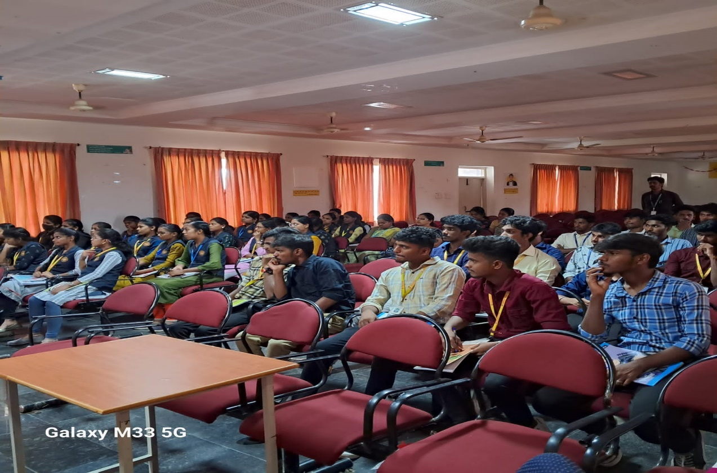

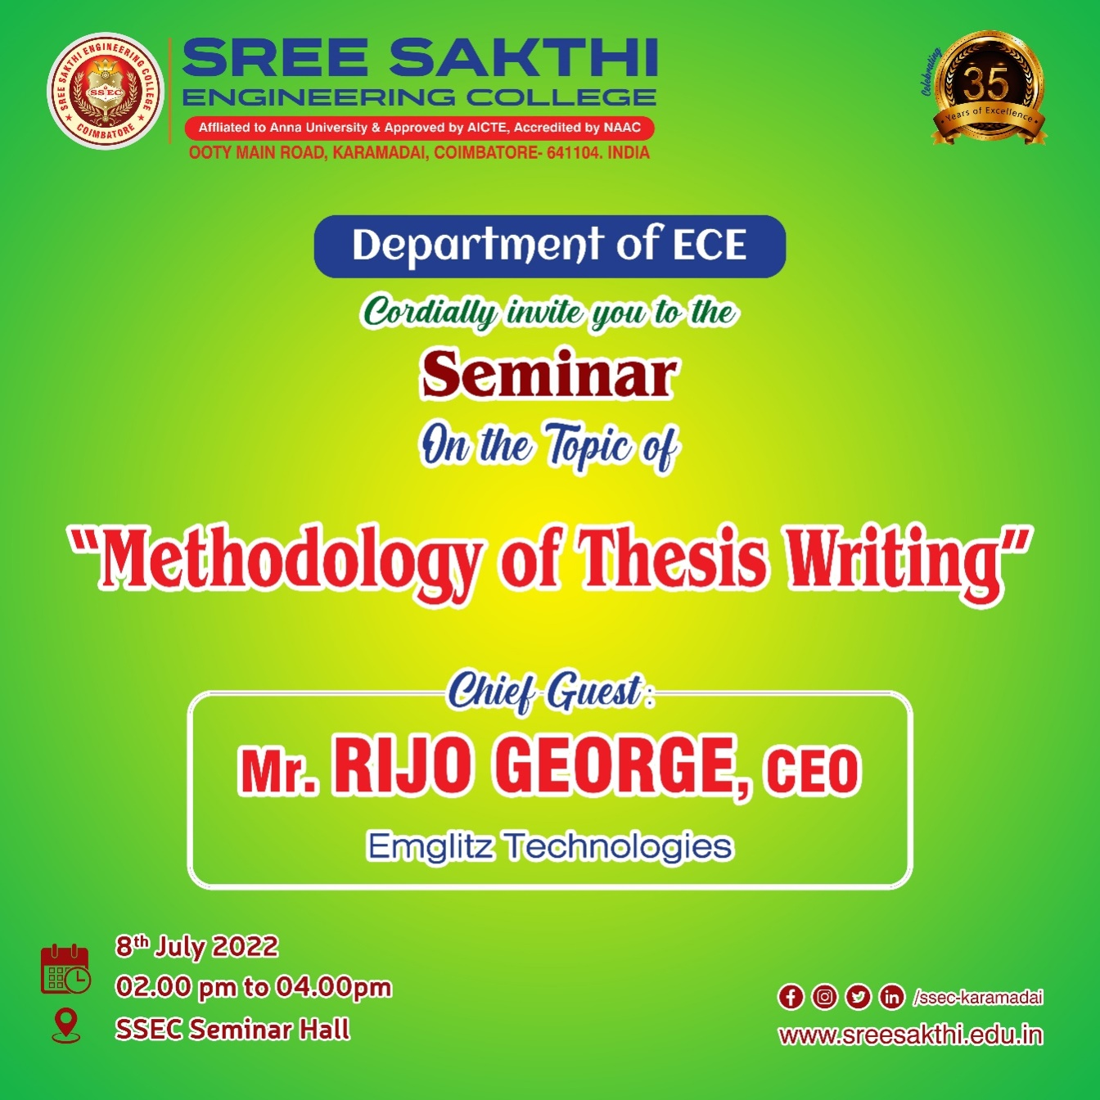

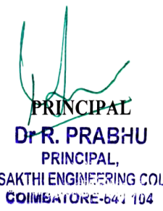

SEMINAR ON “ENTERPRENERSHIP” FOR EEE DEPARTMENT STUDENTS”
Entrepreneurship is the ability and readiness to develop, organize and run a business enterprise, along with any of its uncertainties in order to make a profit. The most prominent example of entrepreneurship is the starting of new businesses.
DETAIL REPORT OF COURSE:
Title : SEMINAR ON “ENTERPRENERSHIP”
Date : 10.3.23
Venue : Power system simulation Lab
Target audience: II, III & IV year EEE students
Resource Person :Mr.CKannan, VEI TECHNOLOGIES Pvt. Ltd., Chennai,
OBJECTIVE OF PROGRAM:
The basic principles of entrepreneurship are:
- Planning a business: While launching a startup, you need to smartly build strategies for establishing the startup. This involves building a vision, assessing financial risks, gathering team members, and planning out a contingency plan. Without a proper plan, a business is likely to face losses and failures.
- Starting a business: After planning the administration and management of the business, entrepreneurs can start the business. To start a business venture, owners will have to first register the company and complete legal formalities. They will also need to have a space to start the business operation.
- Operating a business: Once this entrepreneurial venture has been brought legally into existence, it will need capital to fund operations. Entrepreneurs can either bootstrap or invest venture capital in the business. After the business has its working capital, a team must be built, logistics should be managed and processes must be planned.
TOPICS COVERED IN TRAINING:
- Small businesses entrepreneurship: It is a small-cap business that does not turn into a multi-chain organization or a large conglomerate. Small-scale entrepreneurship is initiated through bootstrapping, giving the owner a complete right to profits. In such ventures, entrepreneurs take loans to run the business.
- Scalable startup entrepreneurship: Such a startup is started with high ambitions, including making profits and achieving high growth. For such types of entrepreneurship, there is a requirement for huge funds that require large external investments. These startups aim to compete with established and successful companies.
- Large company entrepreneurship: This type of entrepreneurship is suitable for those owners that have experience of sustaining innovation. Often C-level executives opt for this type of venture. This is the new division created within an established and larger company to offer new variants of its core products. It is an adaption to environment expansions.

Seminar on Entreprenenurship conducted by

VEITechnologies,Chennai
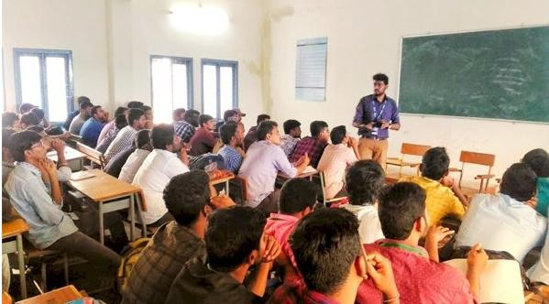

SEMINAR ON “MOTOR CONTROL AND INDUSTRIAL COMPONENT” FOR EEE DEPARTMENT STUDENTS”
The main objective of this course is to promote that For every motor, some form of electrical control is required, from simple ON/OFF to more complex variable speed applications. Motor control devices encompass simple manual controllers, motor contactors and starters, drives and soft starters.

DETAIL REPORT OF COURSE:
Title : MOTOR CONTROL AND INDUSTRIAL COMPONENT
Date : 19.09.22
Venue : Electrical Machines Lab
Target audience: II, III & IV year EEE students
Resource Person :Mr.J.Kumarasamy, SALZER ELECTRONICS,COIMBATORE

OBJECTIVE OF PROGRAM:
The purpose of a motor control system is to control one or more of the motor output parameters, that is, shaft speed, angular position, acceleration, shaft torque, and mechanical output power. The control of temperature at various points in the motor is also a frequent objective of motor control systems.

TOPICS COVERED IN TRAINING:
- AC motor Controller
- DC motor Controller
- Servo motor controller
- Motor Controllers and Drives — Applications and Industries

SeminaronMotorcontrolandIndustrialComponentsconductedby

SalzerElectronics,Coimbatore

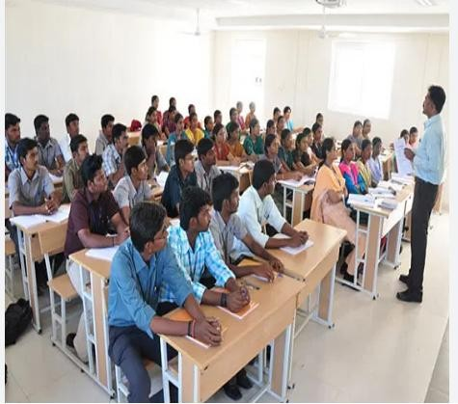

“PCB DESIGN FOR EEE DEPARTMENT STUDENTS”
The goal is to generate a set of files that are used to fabricate and assemble the PCB. If taken time to gather all functional and performance requirements for the new product, and need to design a high-quality PCB for thedevice, then ready to move through the PCB design process. These courses are compliance to industry standard so that they have a simulated experience of the industry.

DETAIL REPORT OF COURSE:
Title : PCB DESIGN
Date : 20.12.23
Venue : ENGINEERING PRACTICES LAB
Target audience: II, III & IV year EEE students
Resource Person :Mr.M.KrishnaKumar, ABE SEMICONDUCTOR DESIGN , Coimbatore

OBJECTIVE OF PROGRAM:
- Understand what a PCB is and how it functions.
- Know the relevant standards which govern PCB installations.
- Be able to read and understand design.
- involves the creation of electrical schematics and drawings that show how components are interconnected.

TOPICS COVERED IN TRAINING:
- PCB Layer fabrication data in Gerber, ODB++, or IPC-2581 file formats
- Pick and place files denoting component locations for assembly
- PCB fabrication and assembly drawings, including notes listing requirements
- A complete BOM with electronic component sourcing information
- A report with testing information, such as test point data and test point locations
Workshopon PCB design conducted
by

ABESemiconductorDesign,Coimbatore

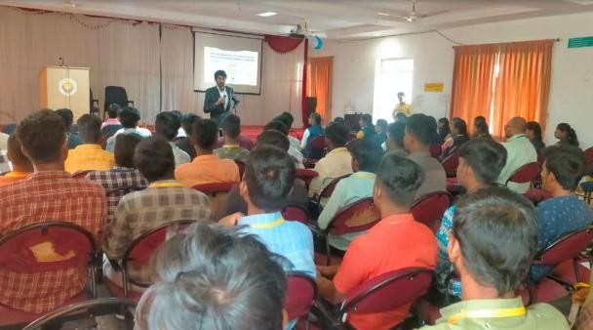

WORSHOP ON INDUSTRIAL DRIVES AND CONTROL FOR EEE DEPARTMENT STUDENTS”
The main objective of this course is about efficient semiconductors optimized for motor control. You can rely on our intelligent power modules (IPMs) and discretes for smart designs in the low-power range. For medium-power drives, our EasyPIM™, EasyPACK™, and EconoPIM™ modules are the perfect match. Moving on to the high-power spectrum, EconoDUAL™ and PrimePACK™ are the solutions of choice. Combined with the innovative.XT interconnection technology, PrimePACK™ modules can help designers overcome the overrating dilemma as they extend the lifetime by raising thermal and power cycling capabilities.. These courses are compliance to industry standard so that they have a simulated experience of the industry.

DETAIL REPORT OF COURSE:
Title : INDUSTRIAL DRIVES AND CONTROL
Date : 14.2.23
Venue : Power electronics Lab
Target audience: II, III & IV year EEE students
Resource Person :Mr.Bharath,ABE SEMICONDUCTOR DESIGN, Coimbatore

OBJECTIVE OF PROGRAM:
- Understand what is industrial drives and how it functions.
- Know the relevant standards which govern drives installations.
- Be able to read and understand control of drives.
- Understand how drives areoperated in a system.

TOPICS COVERED IN TRAINING:
- The handling of development tools.
- Basic knowledge about the structure of the Embedded software, configuration and parameterization of hardware.
- Simulation and Modeling
- An overview Embedded system designusing IOT.

DEPARTMENT OF COMPUTER SCIENCE AND ENGINEERING
EVENT REPORT

S.No | DATE | NAME OF THE EVENT
1 | 13-08-22 | POSTER DESIGNING
2 | 20-8-2022 | GAMMING EVENT
3 | 27-8-2022 | TECH QUIZ
4 | 03-09-2022 | CODE DEBUGGING
5 | 24-09-2022 | WEBSITE DESIGNING
6 | 1-10-2022 | ETHICAL HACKING
7 | 8-10-2022 | TREASURE HUNT(CRYPTOGRAPHY)
8 | 22-10-2022 | TECHNICAL SEMINAR
10 | 29-10-2022 | COGNITIVE TEST
11 | 5-11-2022 | BRAIN STORM
12 | 19-11-2022 | WEBINAR

01. SATURDAY ACTIVITY
NAME OF THE ACTIVITY:POSTER DESIGNING
Program Date : 13.8.2022
Time : 1000. am
Venue : CC1 LAB

ACTIVITY CONDUCTED BY:
- Mrs.SelvaSheela K HOD/CSE
- Ms.Vinothini S AP/CSE
- Ms.Swetha S AP/CSE
- Mrs.Nithya D AP/CSE
Program Details:
One of the main reasons event posters have become a staple in marketing is their affordability. Even an ambitious design, like the one below, can be designed and printed without hurting the budget. When your logo, brand colors, and fonts appear on your

poster. This encourages potential attendees to engage with event campaign.Every students actively participated and involved in both designing and editing posters. Editing is more important in this recent technology. Many of the students designed well and poster designing event is well organized and successfully conducted.
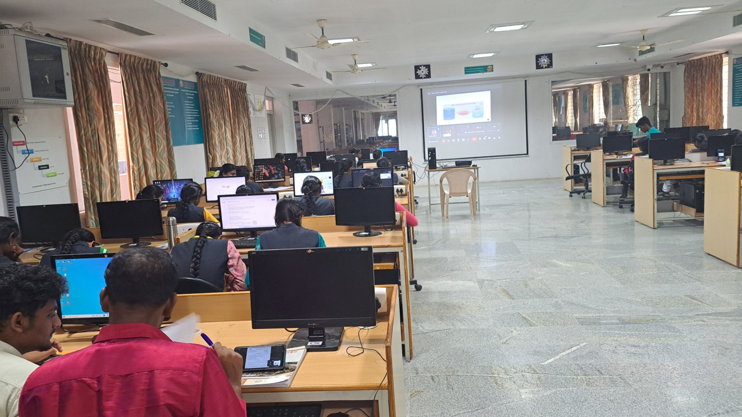

02. SATURDAY ACTIVITY
NAME OF THE ACTIVITY:TECHNICAL GAMMING EVENT
Program Date : 20.8.2022
Time : 1000. am
Venue : CC2 LAB
ACTIVITY CONDUCTED BY:
- Mrs.SelvaSheela K HOD/CSE
- Ms.Vinothini SAP/CSE
- Ms.Swetha S AP/CSE
Program Details:
Technology innovations today are making gaming almost life-like, by building immersive game experiences, while big data and analytics is accelerating insights for identifying strategies for user acquisition, offering personalized gameplay, and building games suitable for a large and ever expanding demographic. As the gaming industry evolves from traditional consoles or computer-based games to cloud-hosted game ecosystems and the metaverse.
Gamming event is conducted for II,III,IV Year students, students actively participated in Technical gamming event.
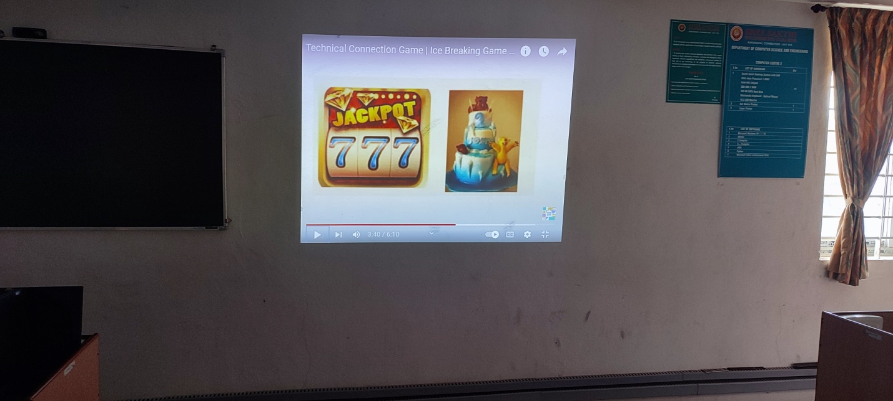

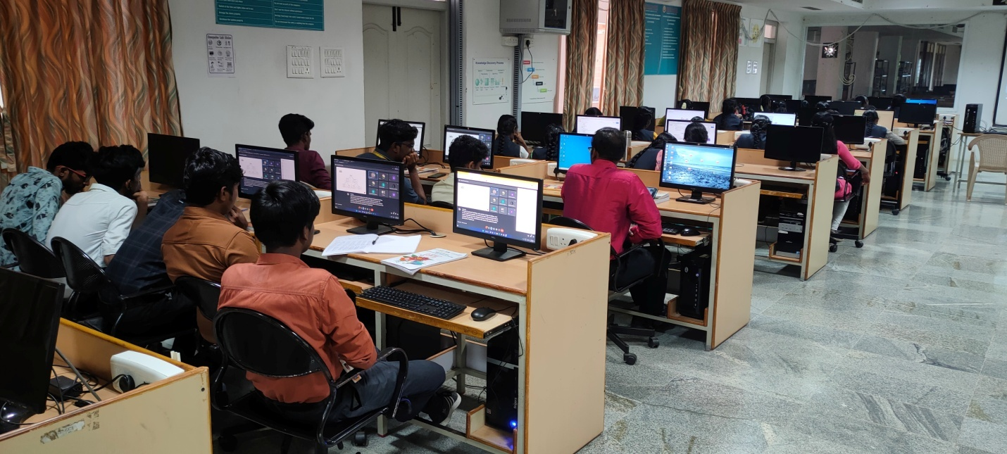

03. SATURDAY ACTIVITY
NAME OF THE ACTIVITY:TECHNICAL QUIZ
Program Date : 27.08.2022
Time : 10.00. am
Venue : CC1 LAB
ACTIVITY CONDUCTED BY:
- Mrs.SelvaSheela K HOD/CSE
- Mrs.Santhiya AP/CSE
- Ms.Swetha AP/CSE

Program Details:
The aim of this activity is to evaluate the knowledge of the students within academics as well as beyond academics and to make them familiar with the prospects of quizzes and the objectivity of the questions. The students were engaged in challenging and thought-provoking questions. The main purpose of the activity is to develop interest in subject areas,emerging technologies and competitive aspects.
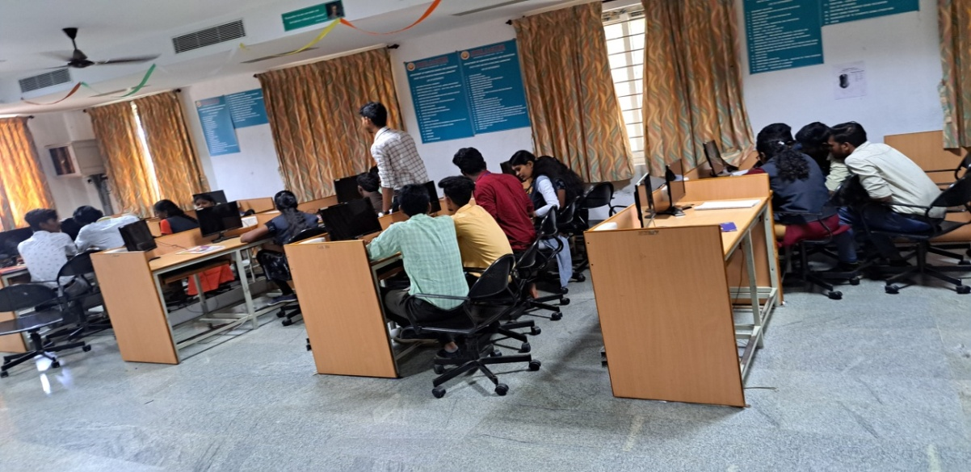

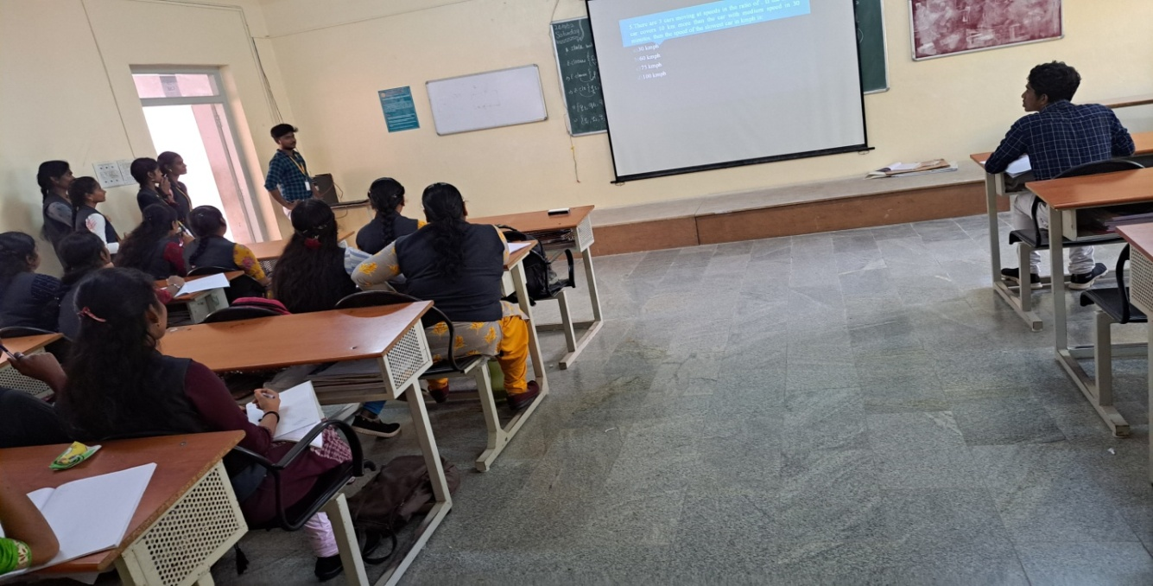

04. SATURDAY ACTIVITY
NAME OF THE ACTIVITY:CODE DEBUGGING
Program Date : 03.09.2022
Time : 1000. am
Venue : CC2 LAB

ACTIVITY CONDUCTED BY:
- Mrs.SelvaSheela K HOD/CSE
- Mrs.Santhiya AP/CSE
- Ms.Swetha SAP/CSE

Program Details:
Debugging is the method you use to determine the state of your program at any point of execution. Use debugging to help you solve problems and to test and confirm program execution.Use a debugger to stop program execution so you can see the state of the program at a specific point. This enables you to view the values of input parameters, output parameters, and variables at the specified point. When program execution is stopped, you can review the code line-by-line to check such issues as flow of execution and data integrity.Each and every students utilized code debugging and gained more knowledge about programming and spotting the errors. Code debugging is well organized and successfully conducted.
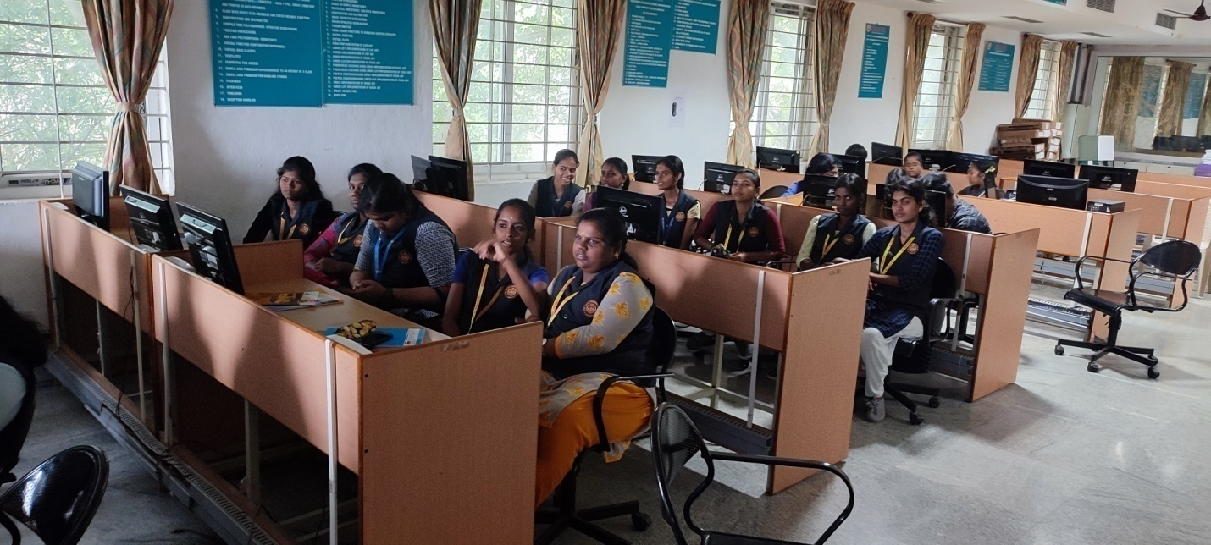

05. SATURDAY ACTIVITY
NAME OF THE ACTIVITY:WEBSITE DESIGNING
Program Date : 24.09.2022
Time : 10.00. am
Venue : CC1 LAB

ACTIVITY CONDUCTED BY:
- Mrs.SelvaSheela K HOD/CSE
- Ms.Swetha AP/CSE
- Ms.Vinothini S AP/CSE
- Mrs.Nithya D AP/CSE

Program Details:
Color is an important factor to consider when designing any web page, and this homepage for the Leading Design complementary colors to evoke a sense of warmness The website clearly provides visitors with all the information they're looking for about this year's.Many students designed well and used many accent color to highlight important elements on the page.Saturday activity successfully conducted.
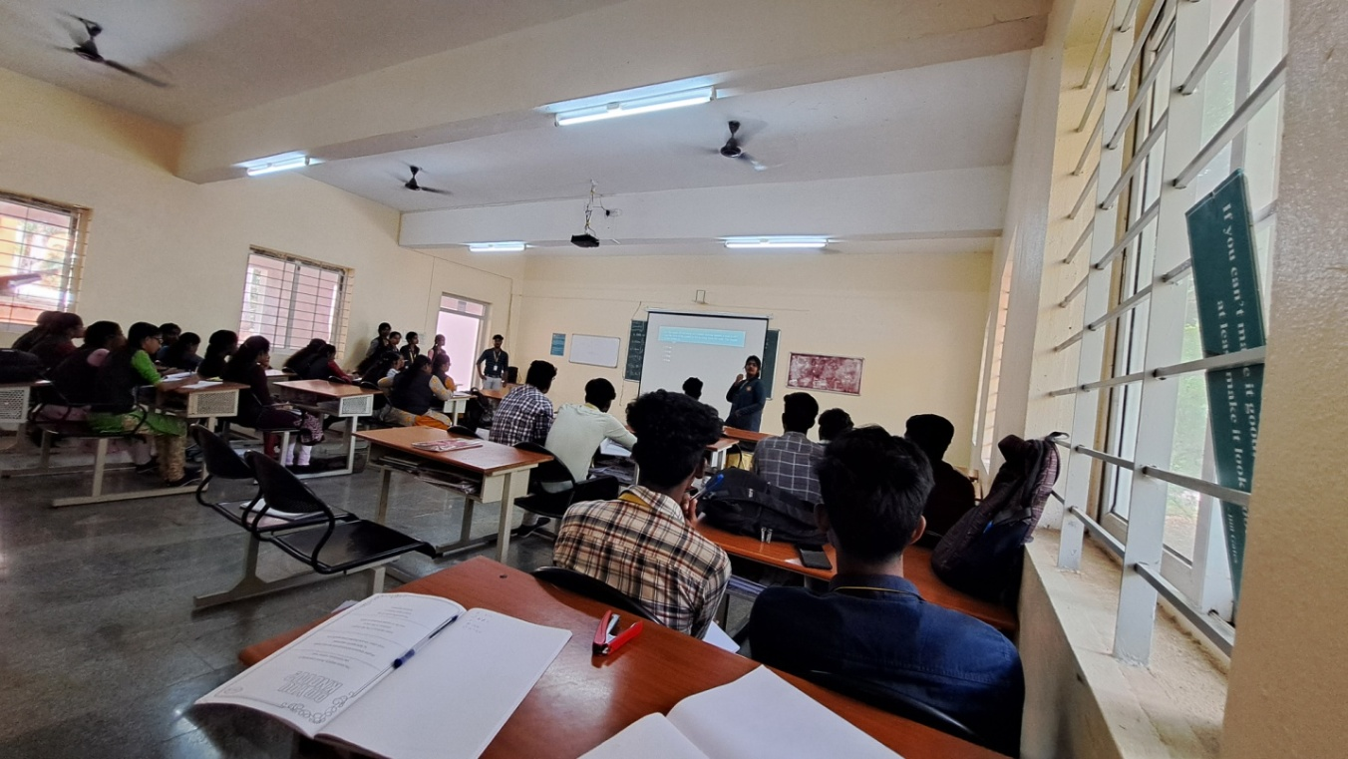

06. SATURDAY ACTIVITY
NAME OF THE ACTIVITY:ETHICAL HACKING
Program Date : 1.10.2022
Time : 10.00. am
Venue : CC2 LAB

ACTIVITY CONDUCTED BY:
- Mrs.SelvaSheela K HOD/CSE
- Ms.Vinothini S AP/CSE
- Ms.Swetha S AP/CSE
- Mrs.Nithya D AP/CSE
Program Details:
Ethical hacking are tasked with the knowledge, skills, and experience to perform risk assessments and test systems for security related issues. These tests are conducted against all possible security breaches, exploits and vulnerability scenarios that protect organizations from attacks.Students actively participated in hacking sessionand well organized.
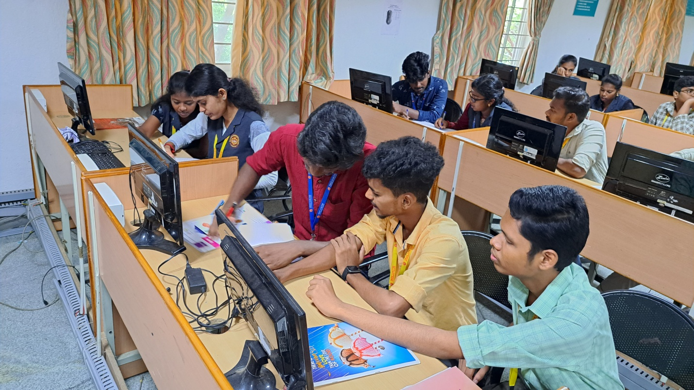

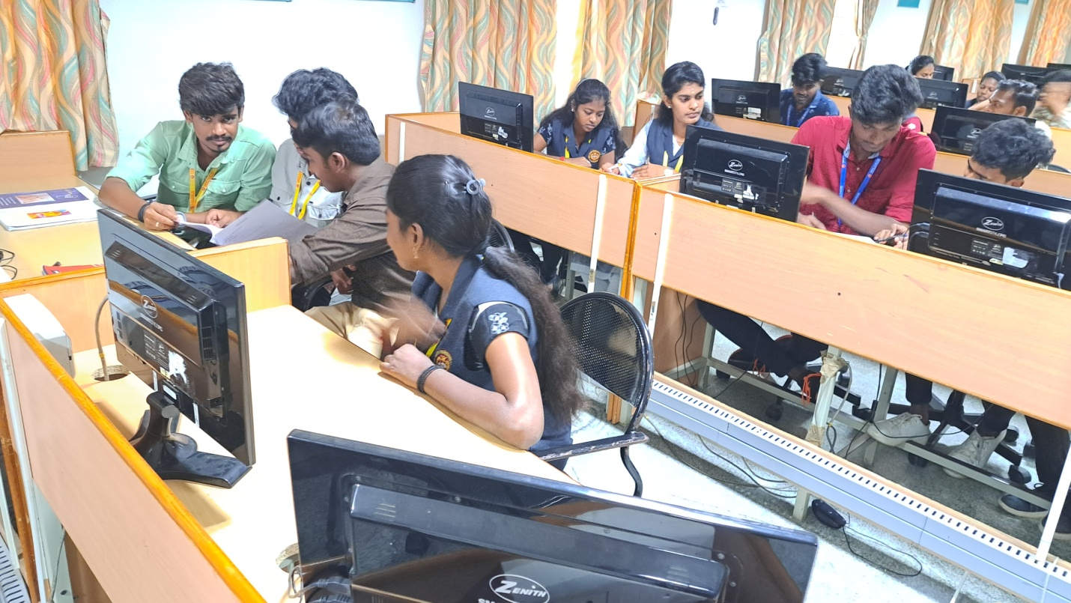

07. SATURDAY ACTIVITY
NAME OF THE ACTIVITY:TREASURE HUNT (CRYPTOGRAPHY)
Program Date : 8.10.2022
Time : 10.00. am
Venue : CC1 LAB
ACTIVITY CONDUCTED BY:
- Mrs.SelvaSheela K HOD/CSE
- Ms.Swetha S AP/CSE
- Ms.Vinothini S AP/CSE
- Mrs.Nithya D AP/CSE

Program Details:
The treasure hunt aims to get groups to try to complete challenges by working as a team and utilising their problem solving skills to come up with strategic plans to help complete the challenges throughout the activity. Students everyone actively participated by forming groups and successfully completed the challenges.
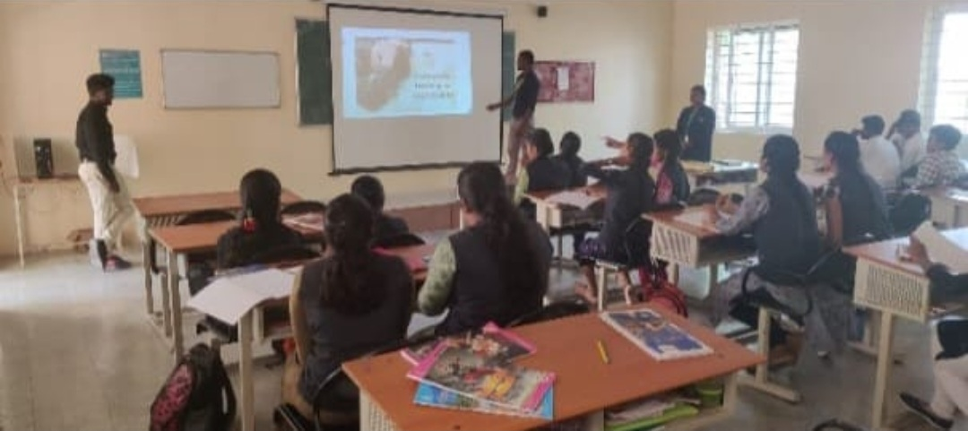
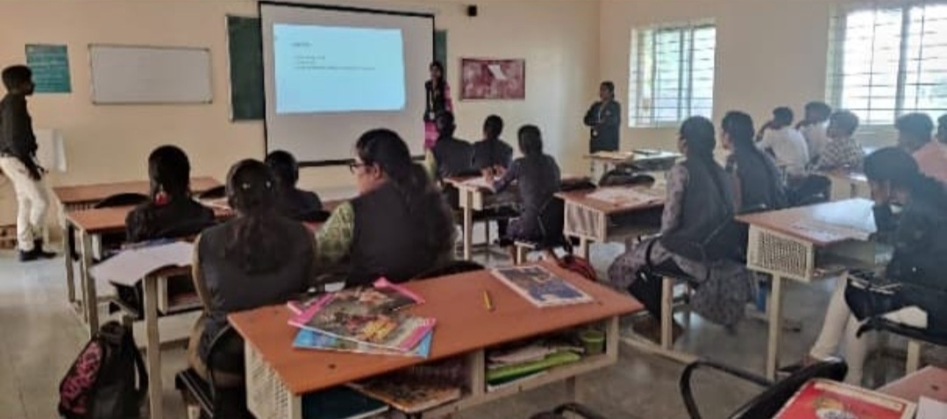

08. SATURDAY ACTIVITY
NAME OF THE ACTIVITY:TECHNICAL SEMINAR
Program Date : 1.10.2022
Time : 10.00. am
Venue : CC1 LAB
ACTIVITY CONDUCTED BY:
- Mrs.SelvaSheela K HOD/CSE
- Ms.Vinothini S AP/CSE
- Ms.Swetha S AP/CSE
- Mrs.Nithya D AP/CSE

Program Details:
Seminars provide a platform and a network to the forest frontline personnel where they can learn from what others are doing, learn about new things, ideas, tricks and important tips related to emerging trends ,Industry 4.0,4G and 5G technologies. This material on Guideline for planning and conducting Seminar emphasizes upon the general guidelines for conduction of seminars. Each and every student participated in technical seminar events. Technical seminar is very useful for the students,and the activity is well organized.
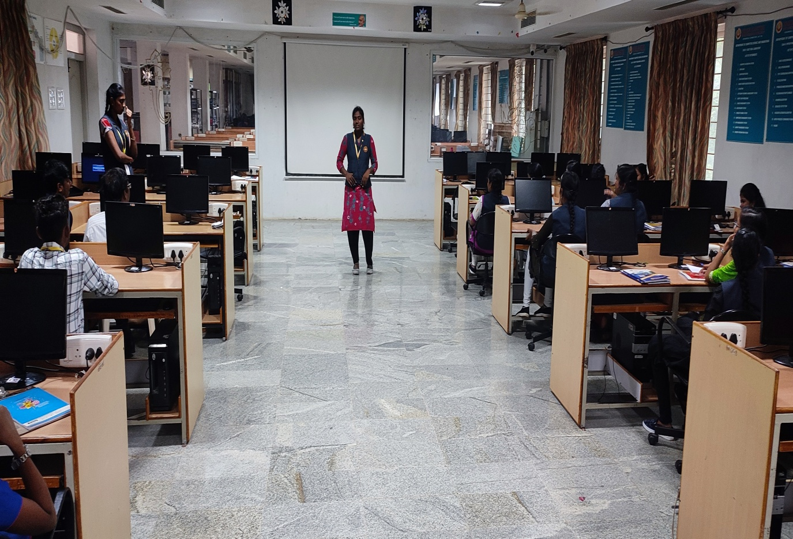
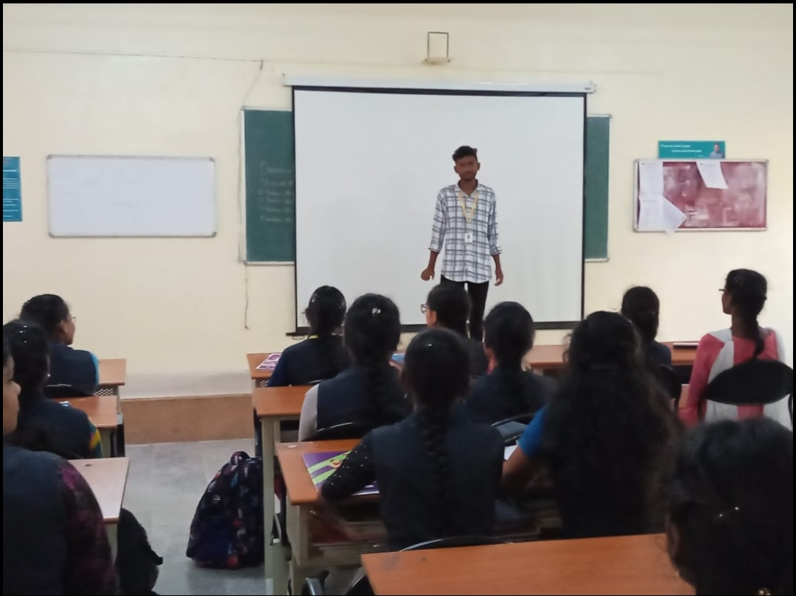

10. SATURDAY ACTIVITY
NAME OF THE ACTIVITY: COGNITIVE TEST
Program Date : 29.10.2022
Time : 10.00. am
Venue : CC1 LAB

ACTIVITY CONDUCTED BY:
1.Mrs.SelvaSheela K HOD/CSE
2.Ms.Vinothinis AP/CSE
3.Ms.Swetha s AP/CSE
4.Ms.Nithiya D AP/CSE
Program Details:
Department of computer science and engineering conducted Saturday activity for II YEAR, III YEAR, IV YEAR STUDENTS.Cognitive and Brainstorm activity has been conducted. Every students actively participated and involved in both theactivity.Final year students were fully engaged in cognitive test for the purpose of placement. Students involved and actively participated in Saturday activity hour and well organized.
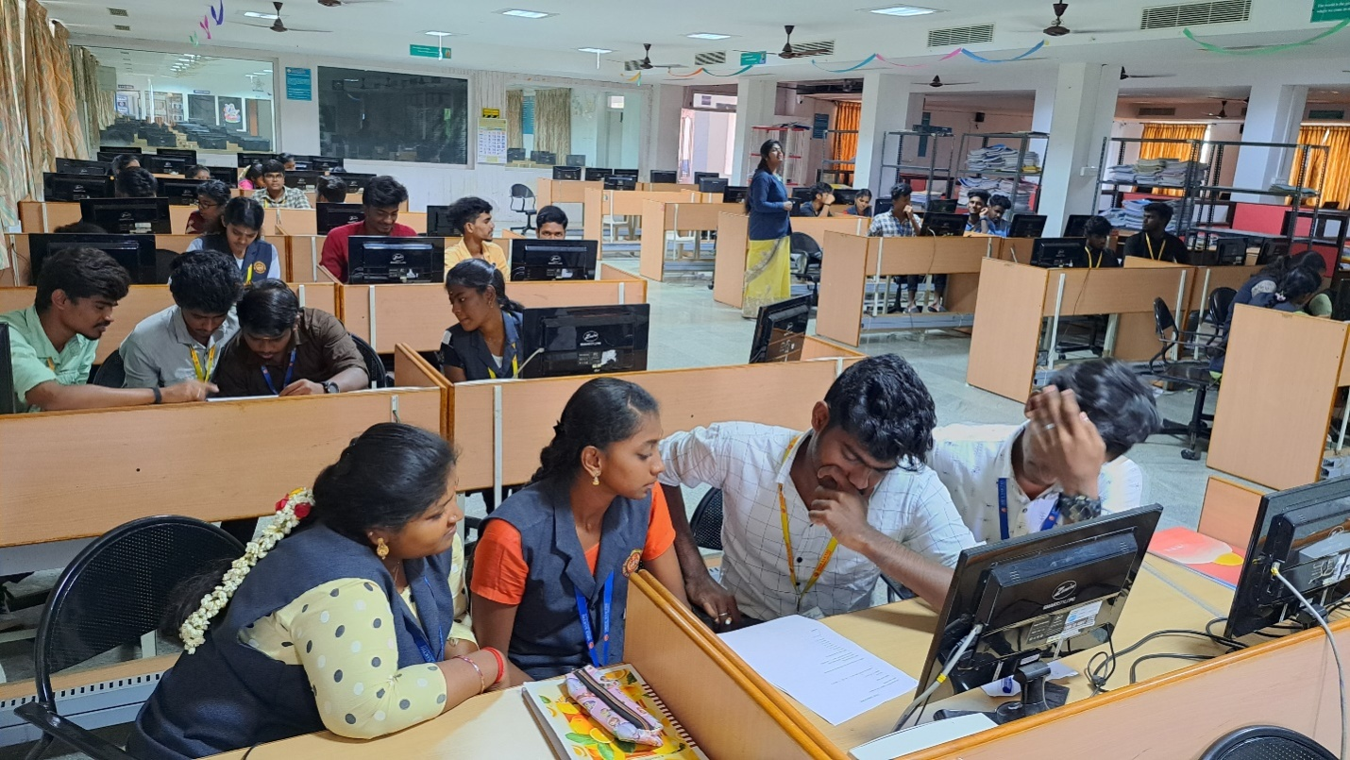
11. SATURDAY ACTIVITY
NAME OF THE ACTIVITY:BRAIN STORM
Program Date : 5.11.2022
Time : 10.00. am
Venue : CLASS ROOM NO:103
ACTIVITY CONDUCTED BY:
- Mrs.SelvaSheela K HOD/CSE
- Ms.Swetha S AP/CSE
- Ms.Vinothini S AP/CSE

Program Details:
A truly good idea is a great way to motivate the team to do their best work and to get your audience clicking, sharing, and converting. But finding that good idea, let alone filling the editorial content , can be a pretty daunting challenge for content teams.Brainstorm activity is well organized and successfully conducted.

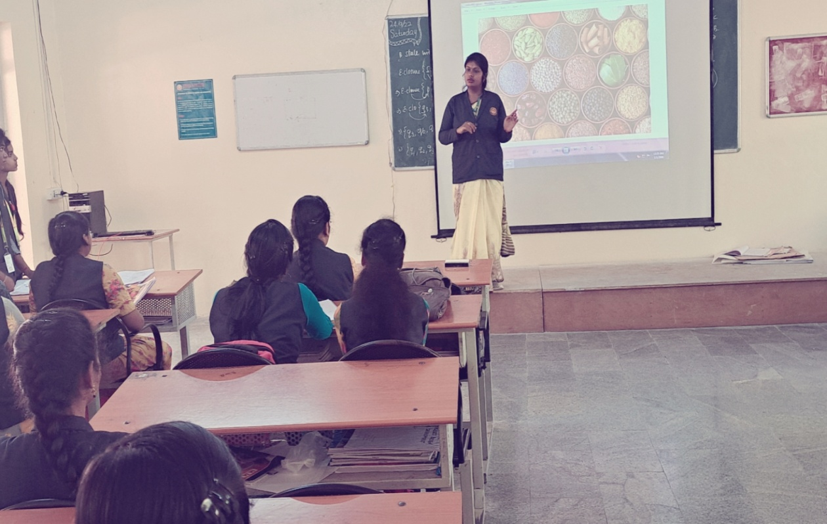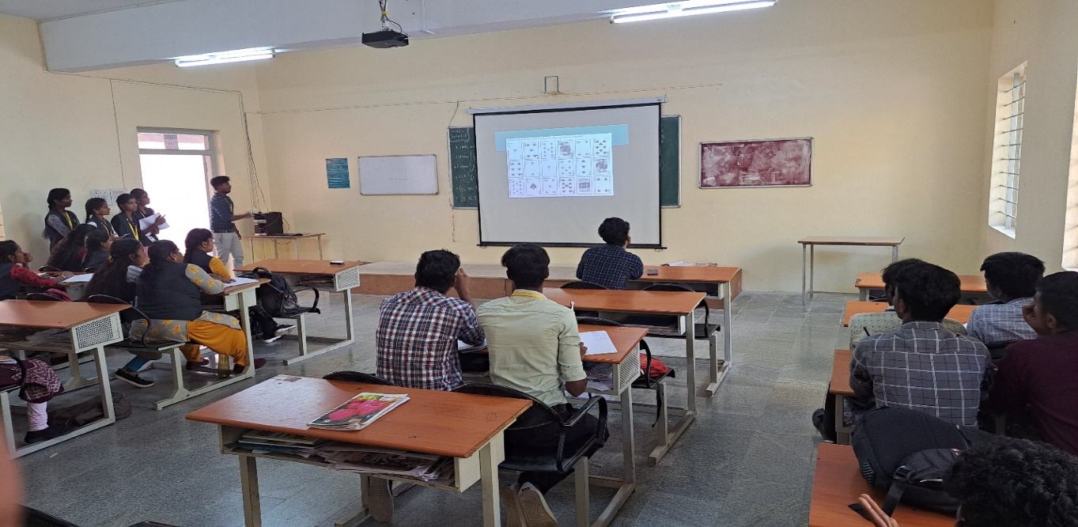
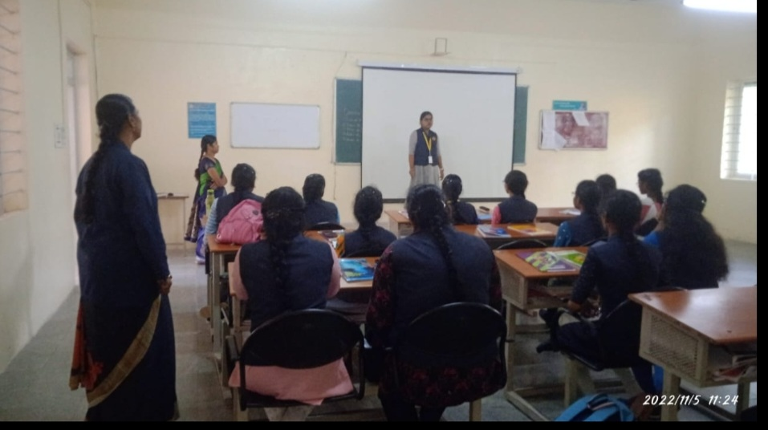
12. SATURDAY ACTIVITY
NAME OF THE ACTIVITY: WENINAR ON MACHINE LEARNING AND
DATA ANALYTICS
Program Date :19.11.2022
Time : 10.00 am
Venue :COMPUTER CENTRE 1
CHIEF GUEST: SATHYA K SENIOR ASSISTANT PROFESSOR
VIT,VELLORE
ACTIVITY CONDUCTED BY:
- Mrs.SelvaSheela K HOD/CSE
- Ms.S.Vinothini AP/CSE
- Ms.S.Swetha AP/CSE
- Ms.D.Nithiya AP/CSE

AGENDA

MEETING TIME : 10:AM TO 12 PM

MEETING VENUE : COMPUTER CENTRE 1

WELCOME ADDRESS : K.SELVA SHEELA HOD/CSE

MEETING HOST : SATHYA K SENIOR ASSISTANT PROFESSOR

STUDENTS HANDS ON :11:30 TO 12:00
SESSION

VOTE OF THANKS :SWETHA S AP/CSE

Program Details:
Department of computer science and engineering conducted Saturday activity WEBINAR ON MACHINE LEARNING AND DATA ANALYTICS for II YEAR, III YEAR, IV YEAR STUDENTS. Every students joined in the webinar conducted by Mrs.SATHYA.K SENIOR ASSISTANT PROFESSOR ,VIT Vellore campus.
Webinar on Machine learning and data analytics is very useful for the students. Each and every students were more interactive in the session by knowing python,pandas and .net. Handson session is also conducted.Students utilized well in the webinar and organized well.

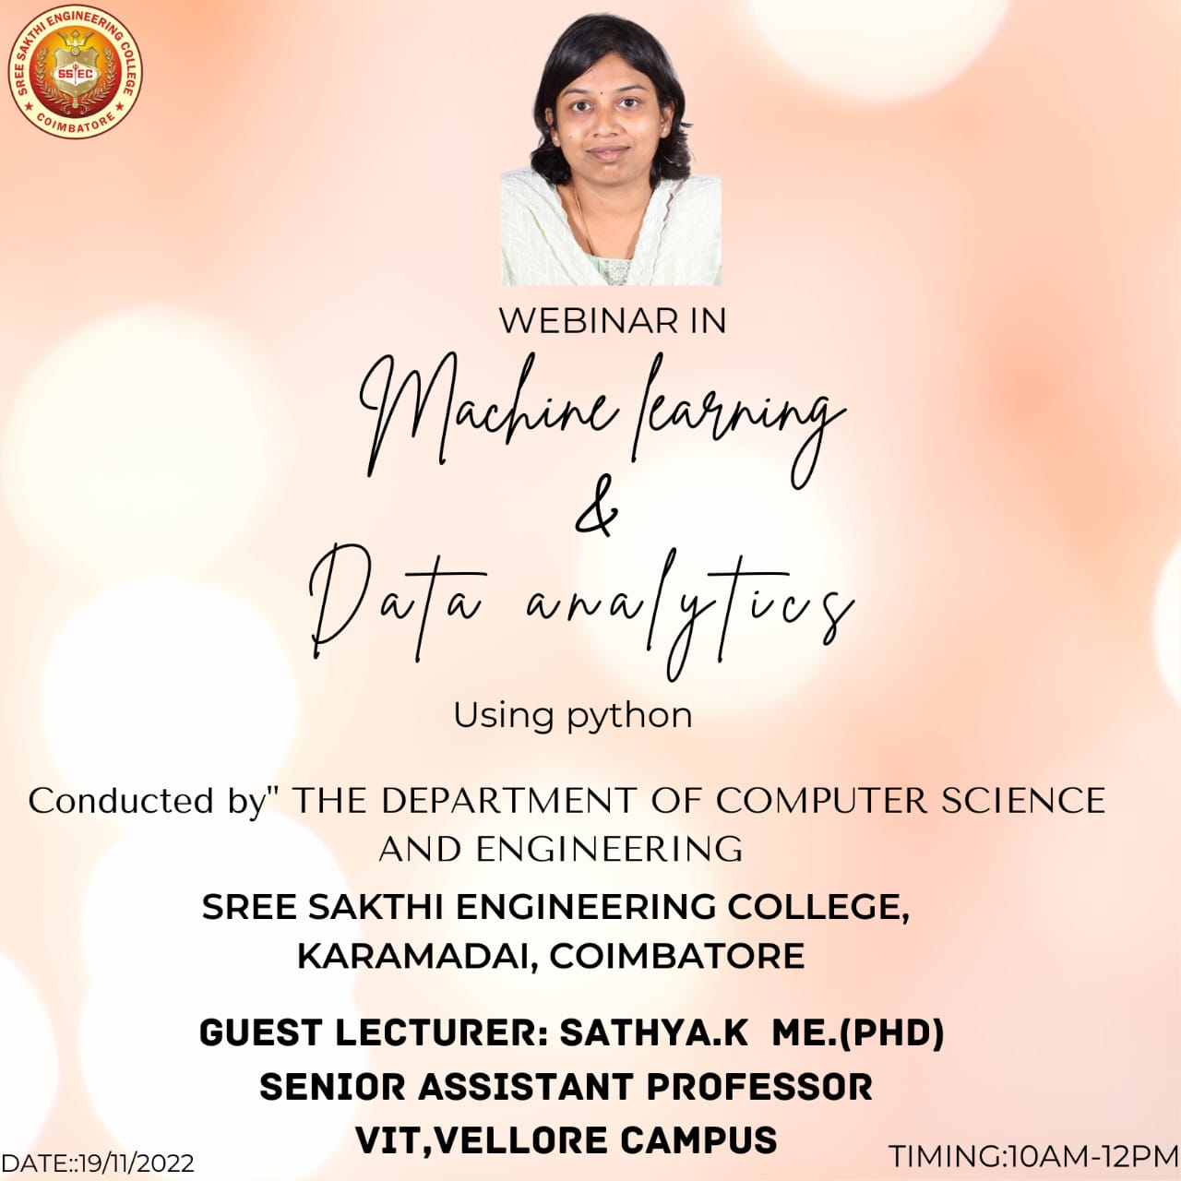
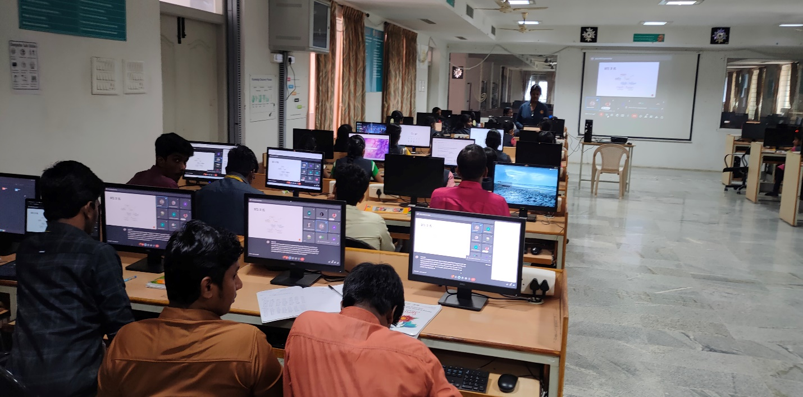
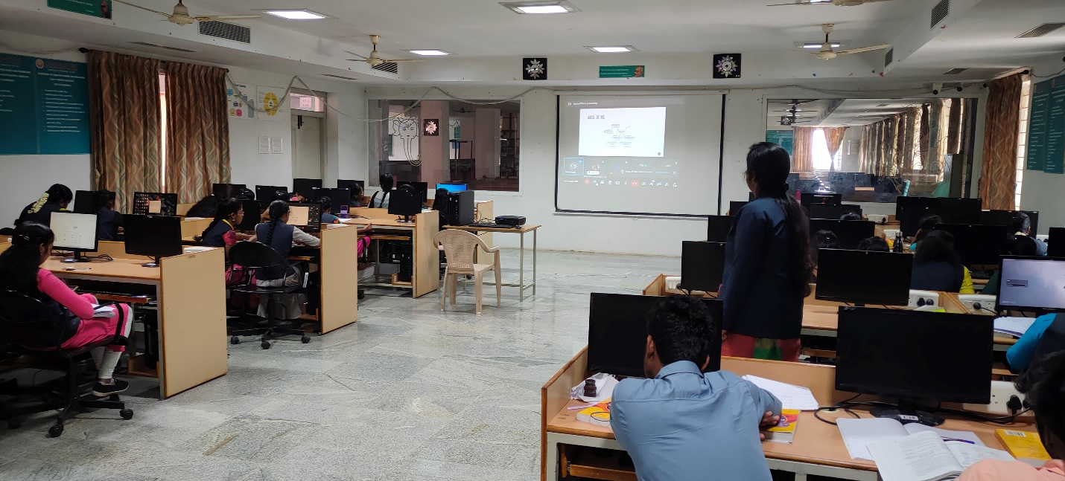

S.No | DATE | NAME OF THE EVENT
1 | 13-08-2022 | POSTER DESIGNING
2 | 20-08-2022 | GAMMING EVENT
3 | 27-08-2022 | TECH QUIZ
4 | 03-09-2022 | CODE DEBUGGING
5 | 24-09-2022 | WEBSITE DESIGNING
6 | 01-10-2022 | ETHICAL HACKING
7 | 08-10-2022 | TREASURE HUNT(CRYPTOGRAPHY)
8 | 22-10-2022 | TECHNICAL SEMINAR
10 | 29-10-2022 | COGNITIVE TEST
11 | 05-11-2022 | BRAIN STORM
12 | 19-11-2022 | WEBINAR

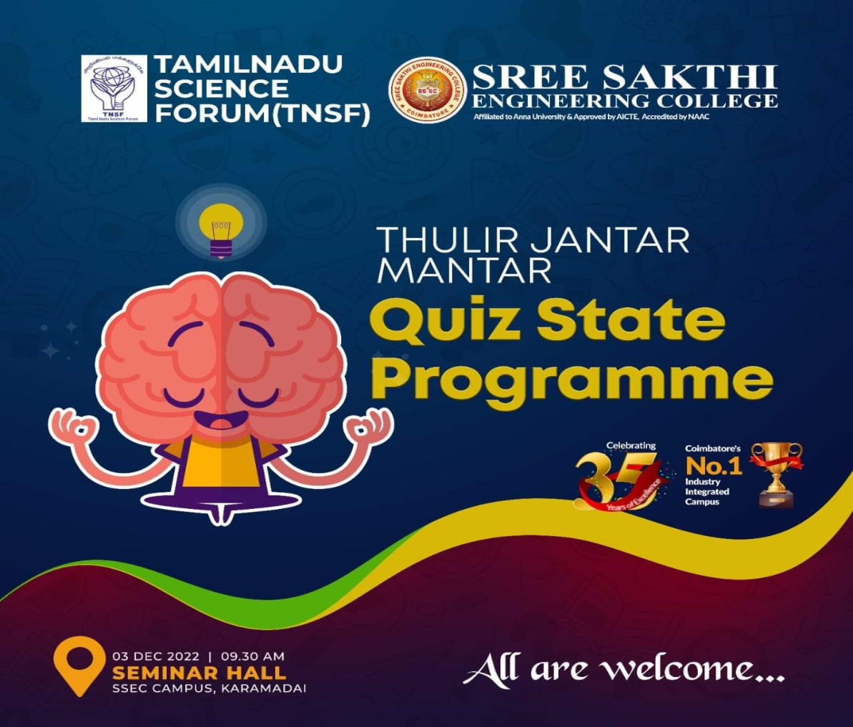
03/12/2022-quiz state programme –motivation program

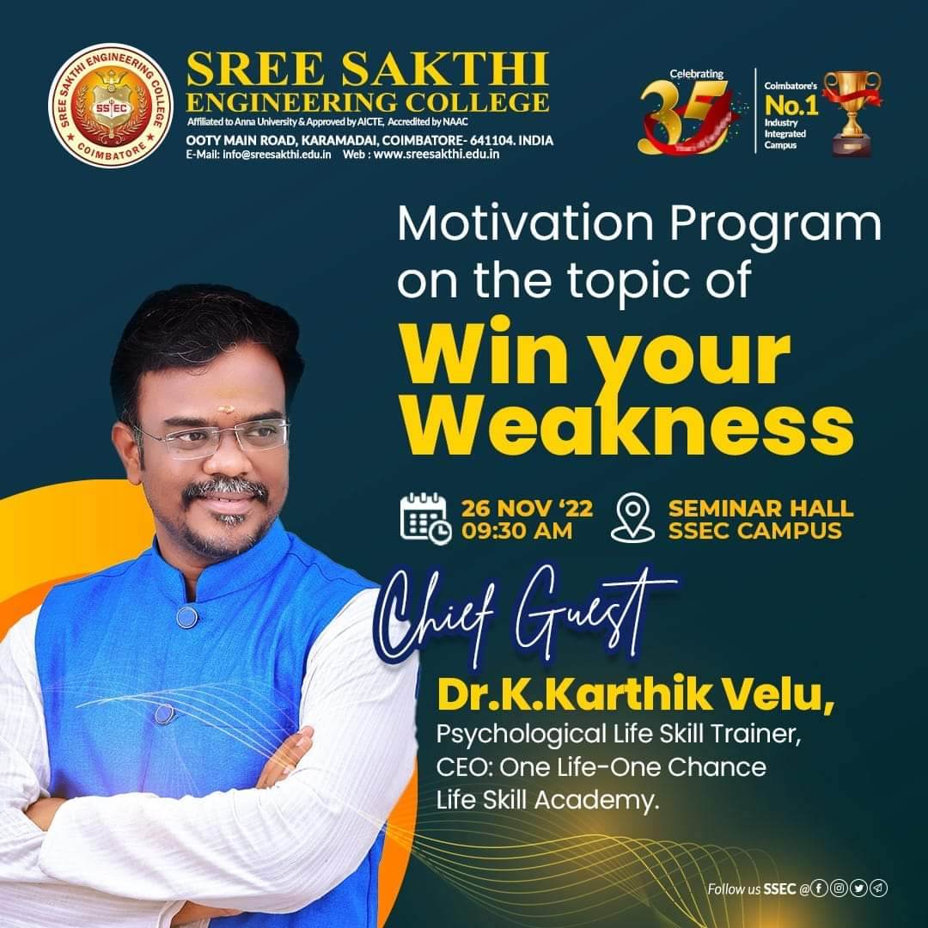

26/11/2022-win your weakness-motivation program

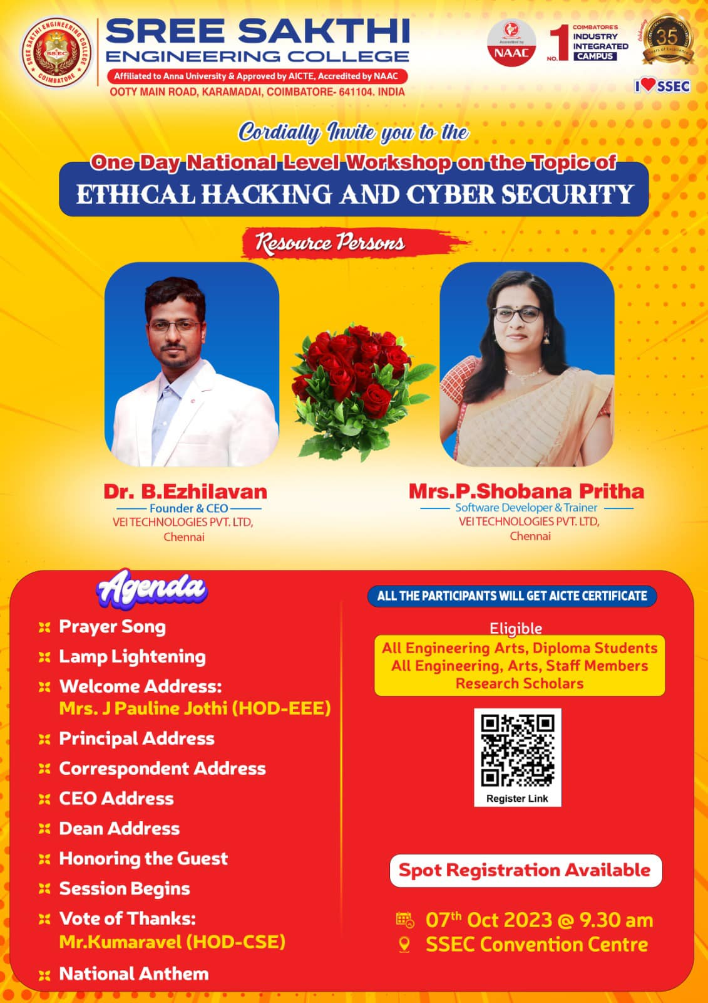
07-10-2023-national level workshop-ethical hacking and cyber security
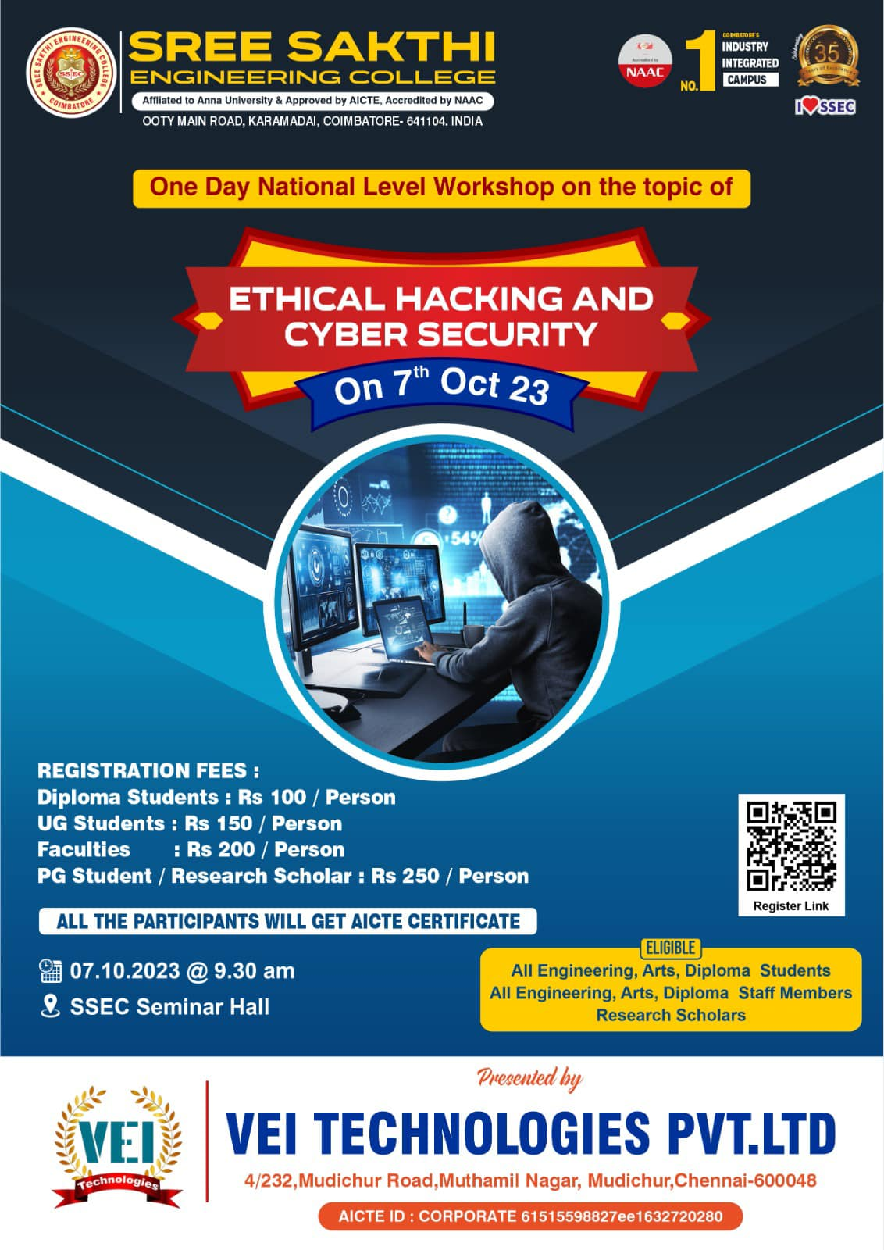

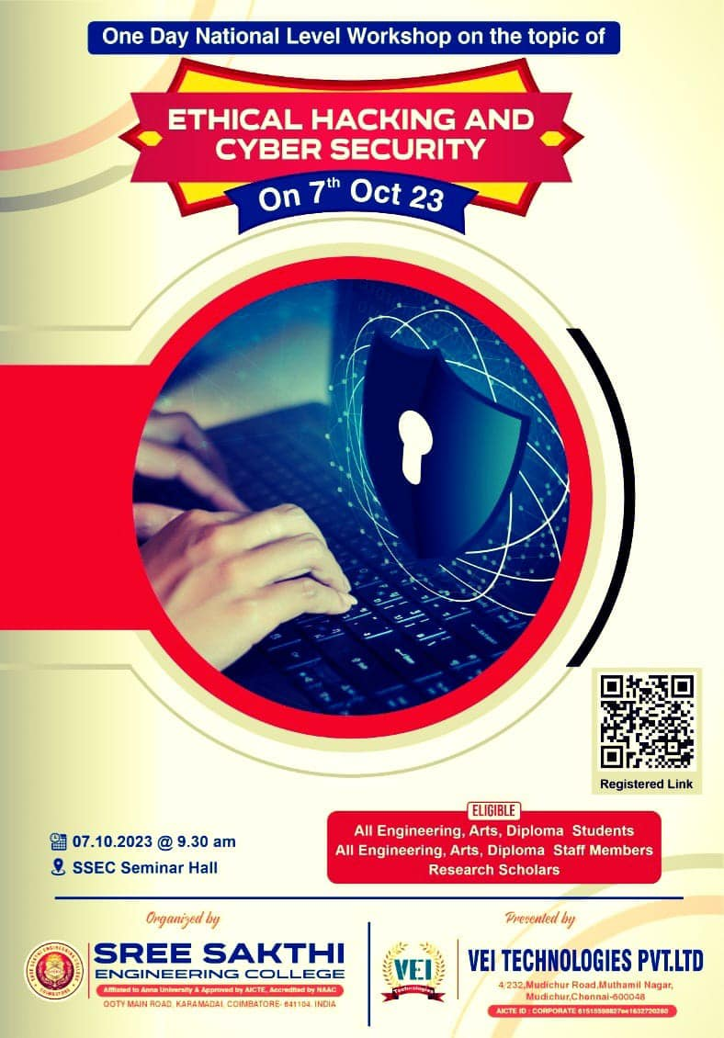

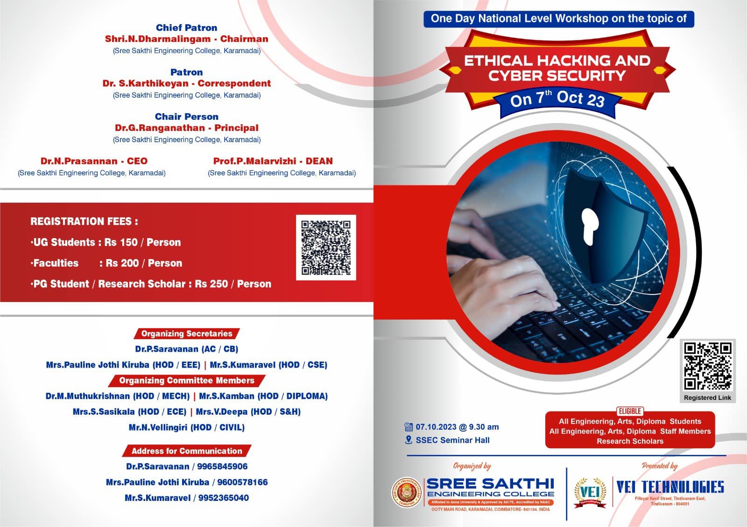

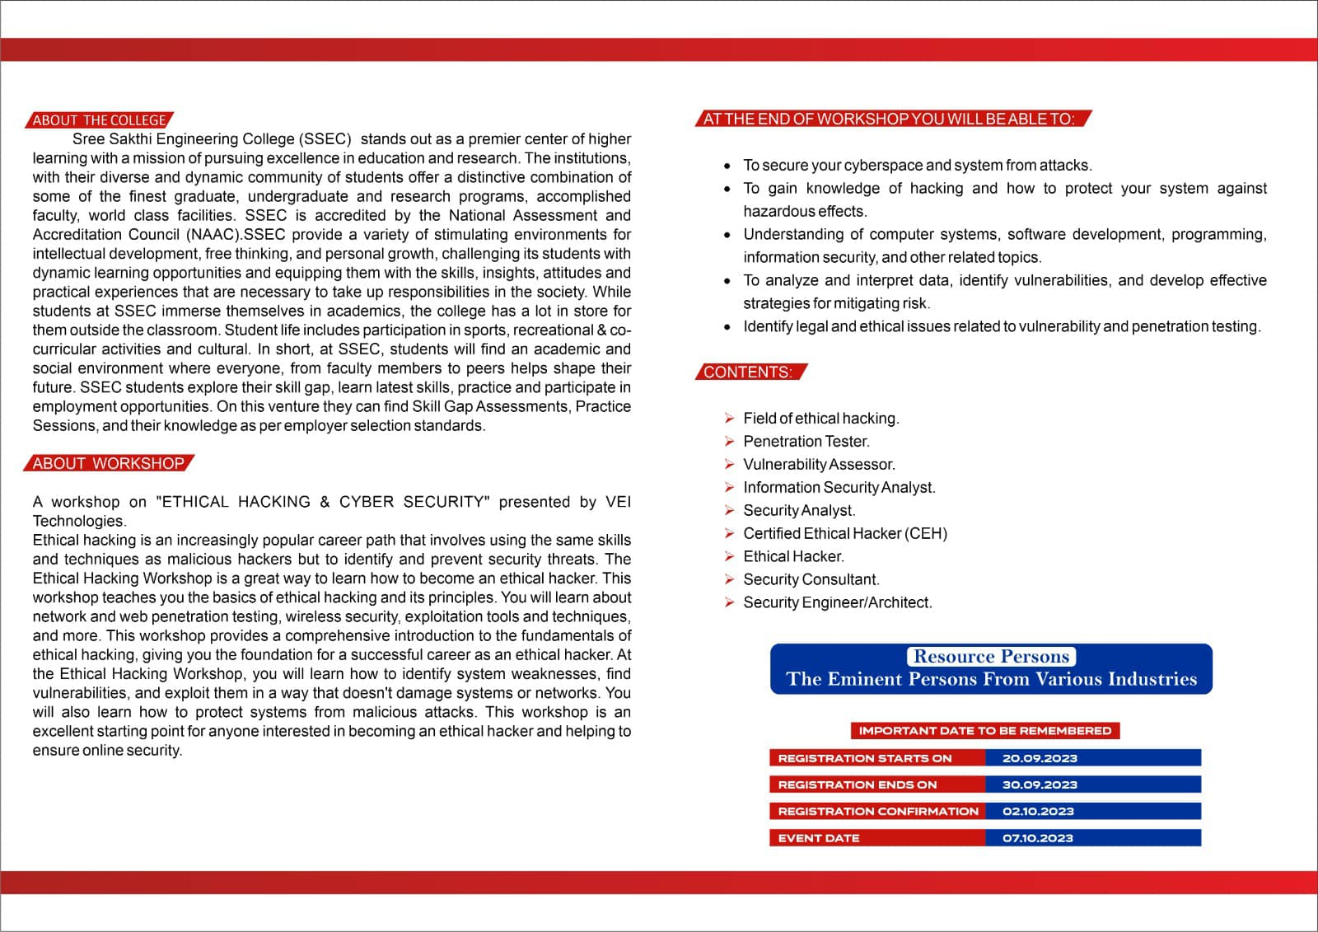
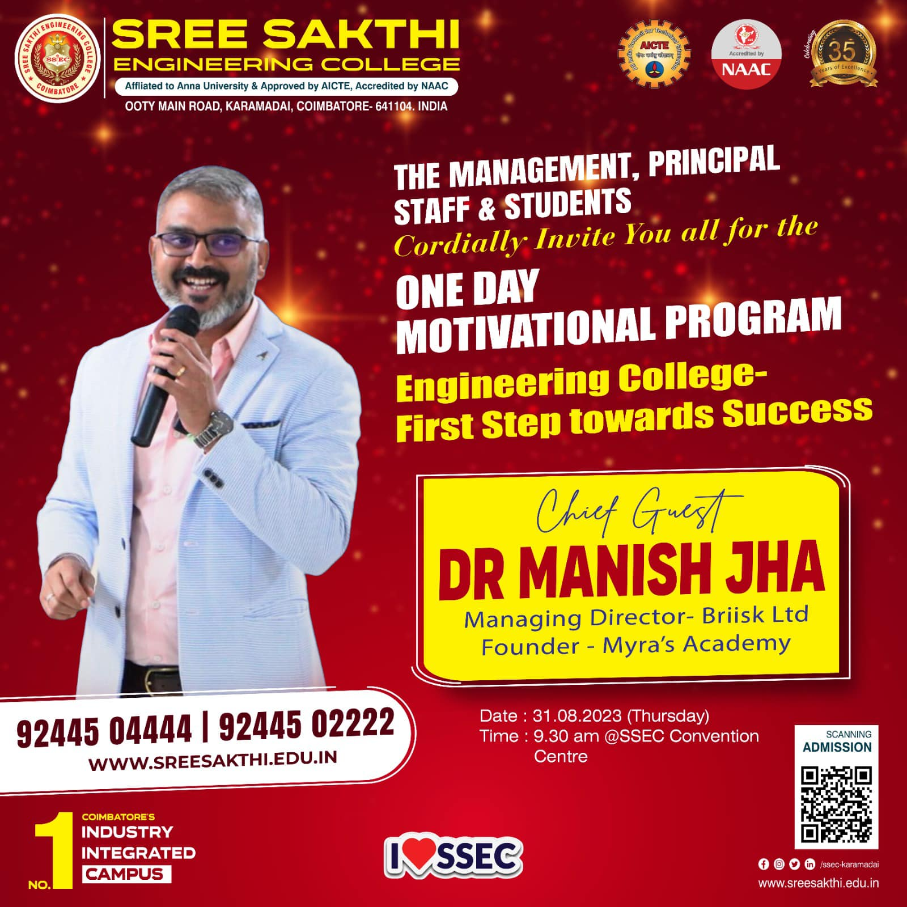

31/08/2023-motivational program –engineering day

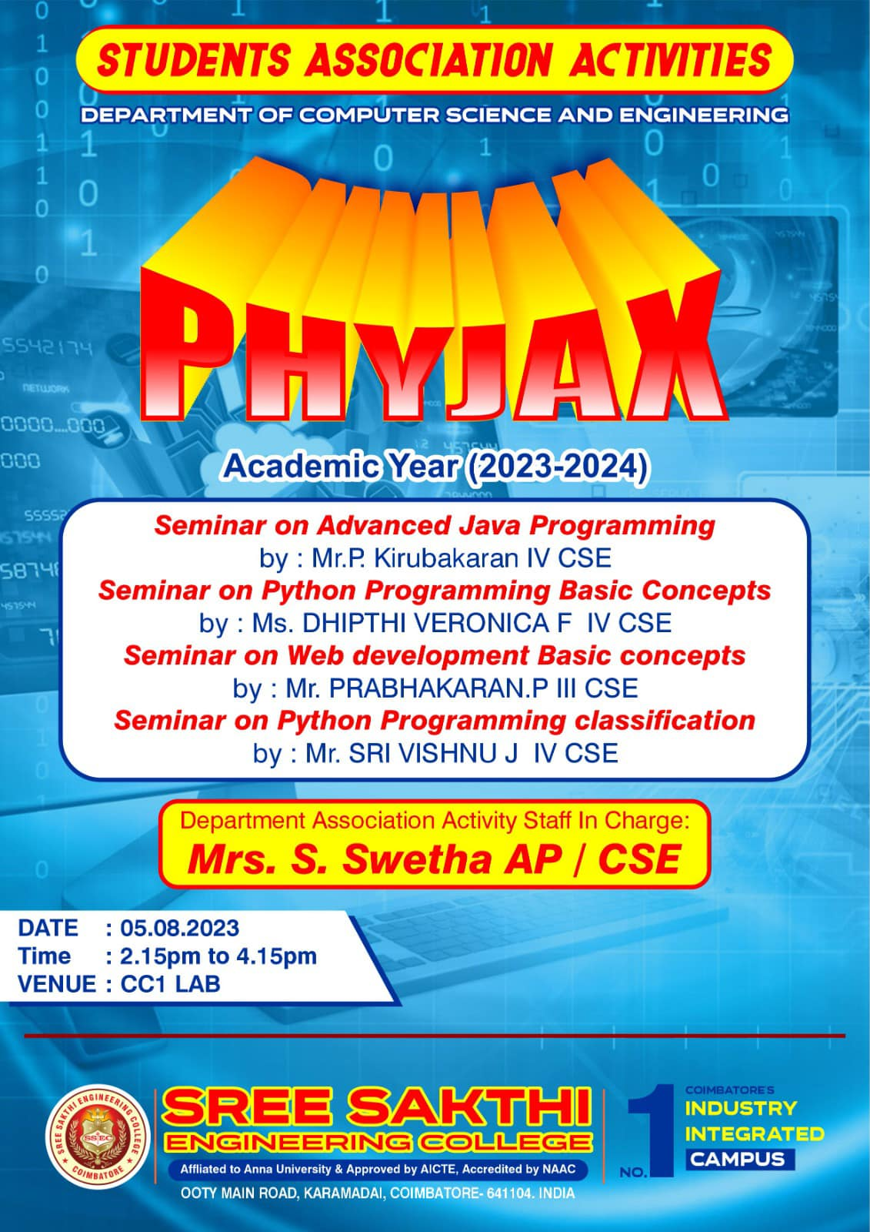
05/08/2023-student associativity activity

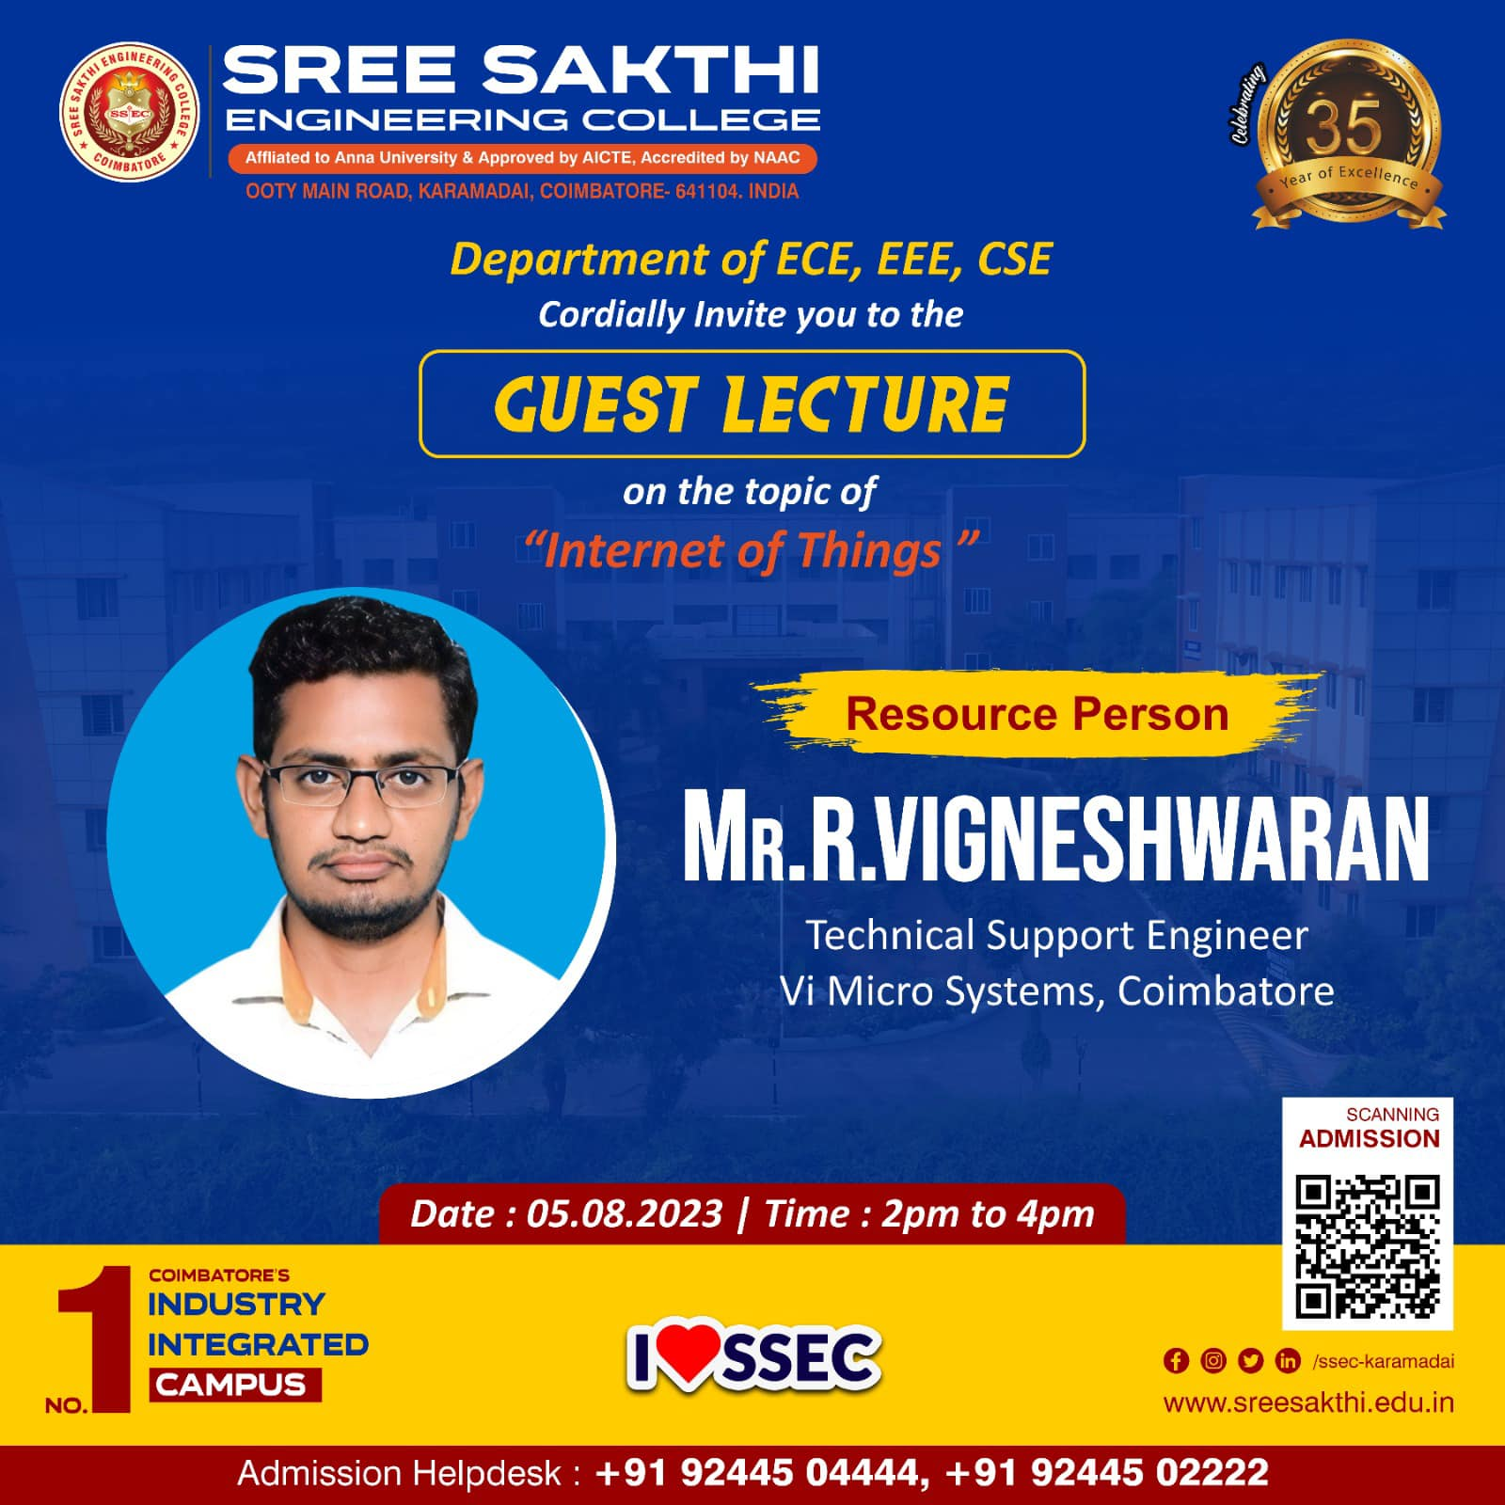

05/08/2023-guest lecturer-internet of things
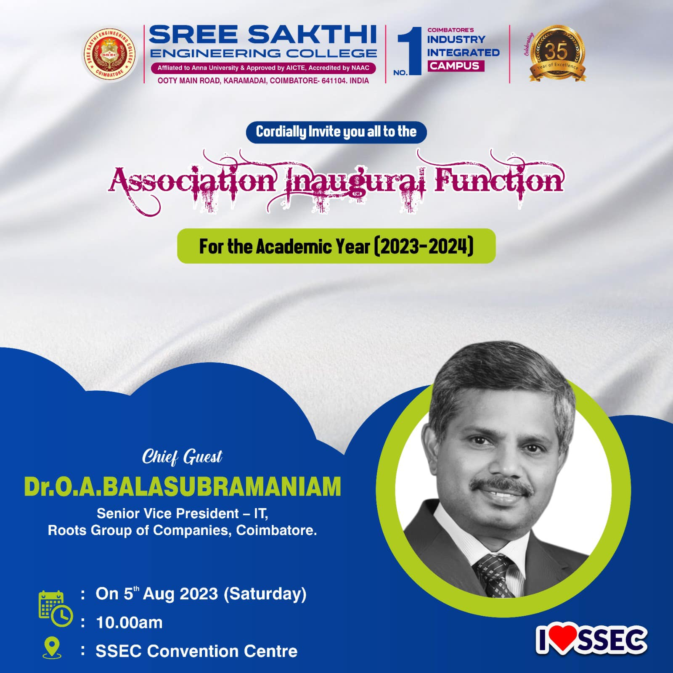
05/08/2023-association inauguration functions -
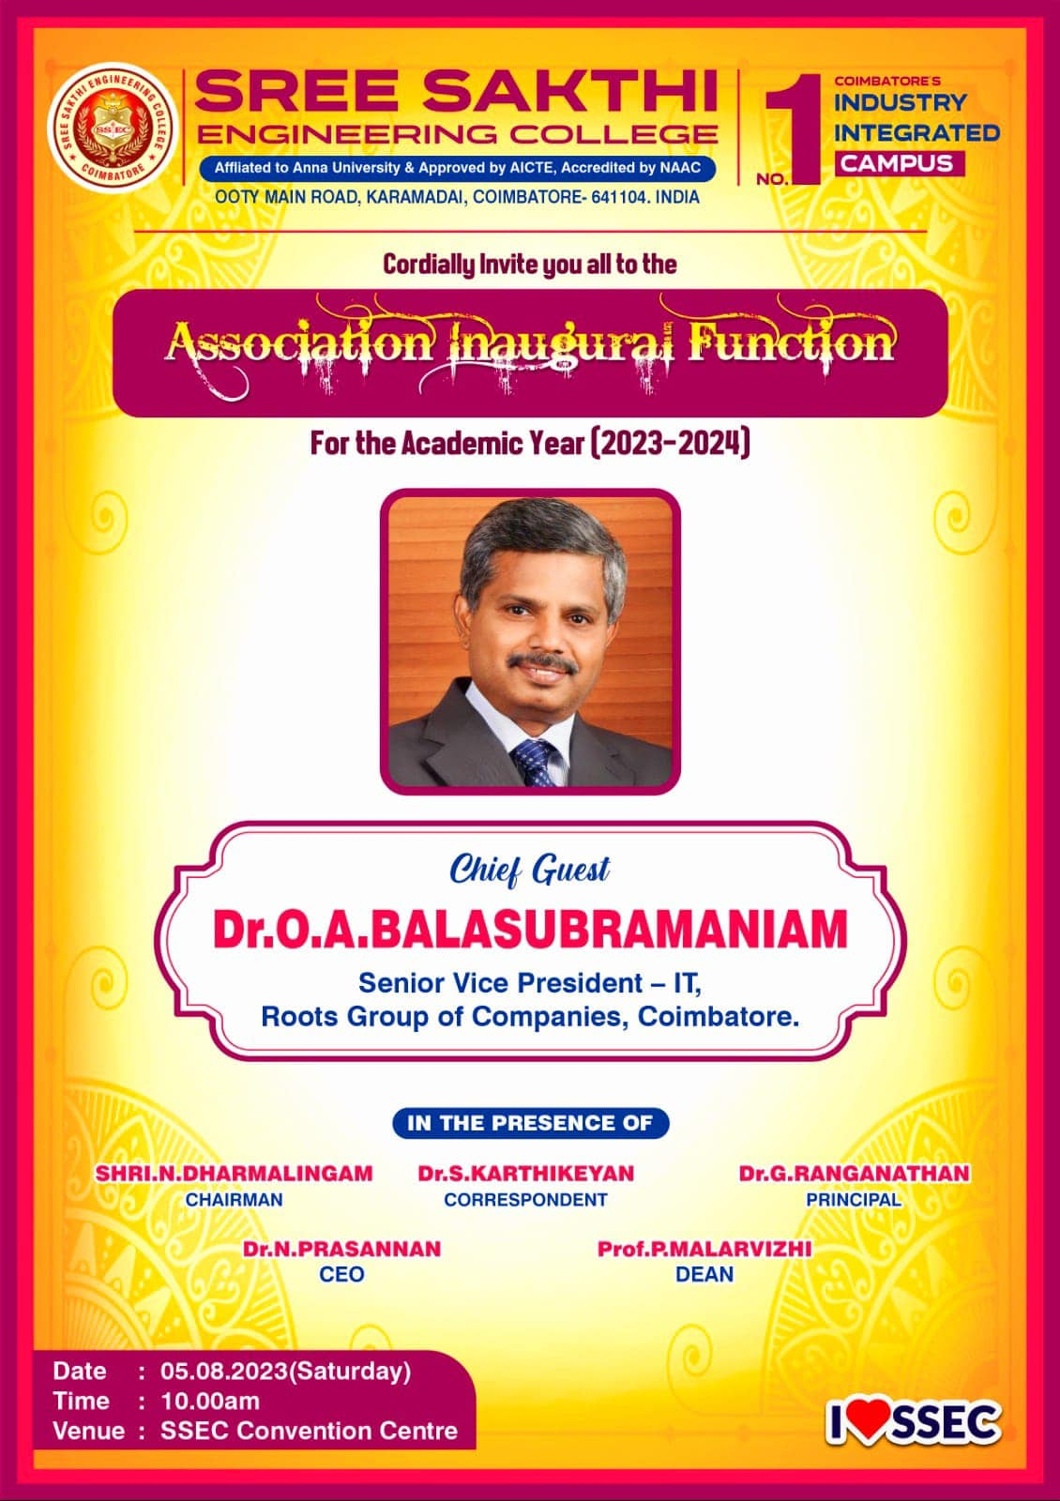
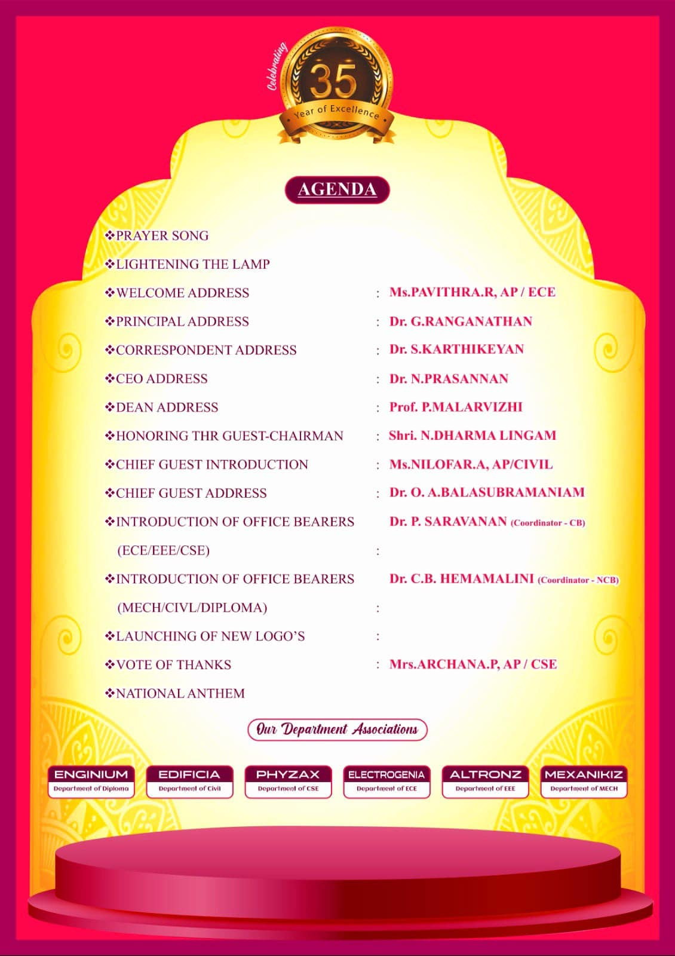
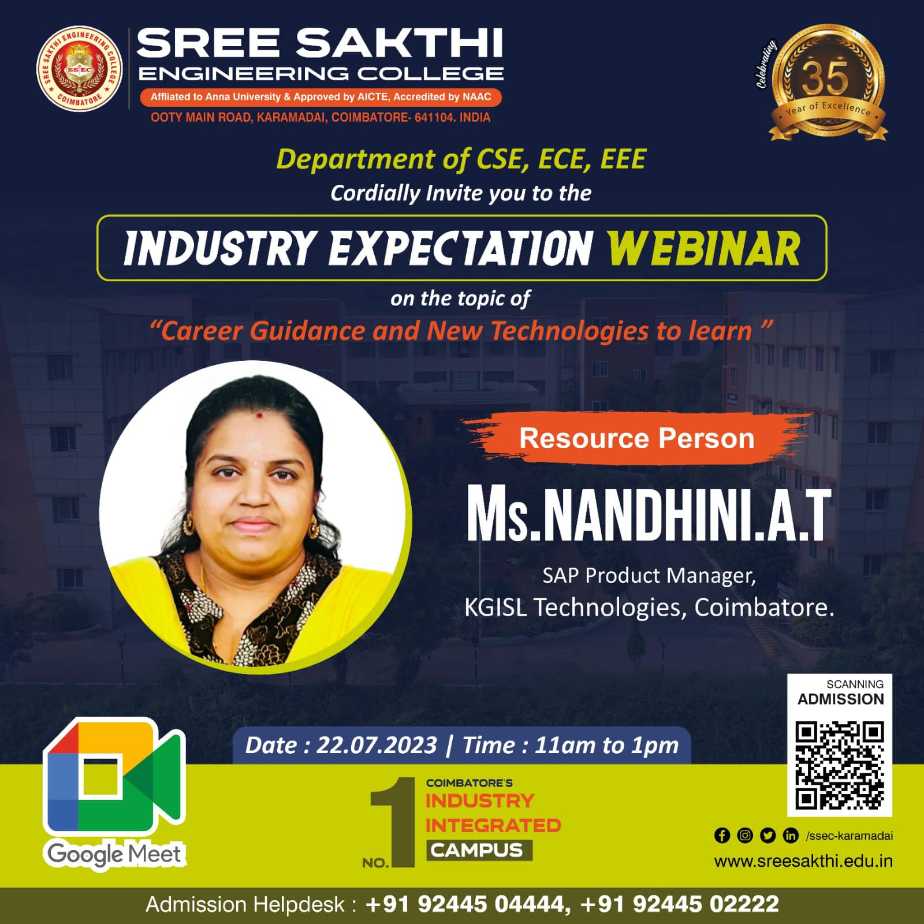

22/07/2023-webinar-carrer guidance and new technologies to learn
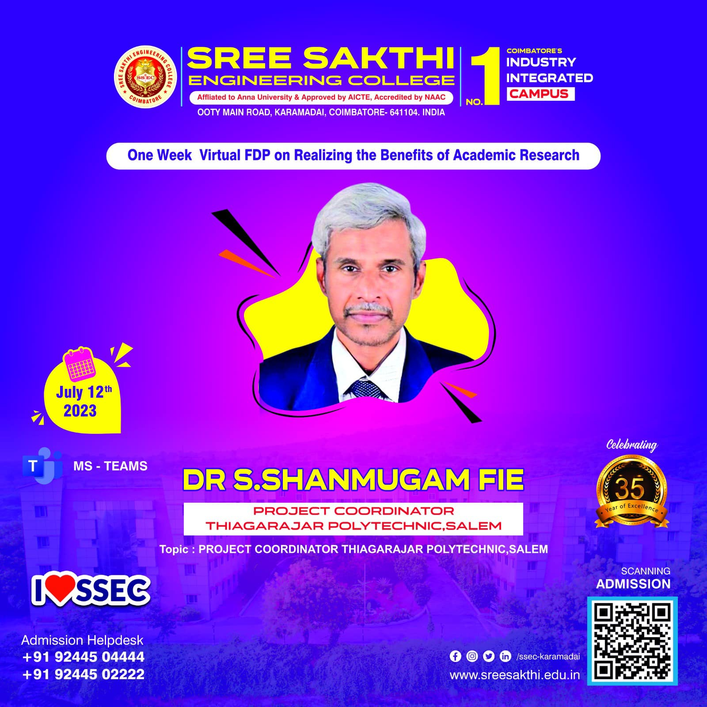
12/07/2023-one week virtual fdp on realizing the benefits of academic research
https://www.facebook.com/SAKTHICOLLEGE/photos
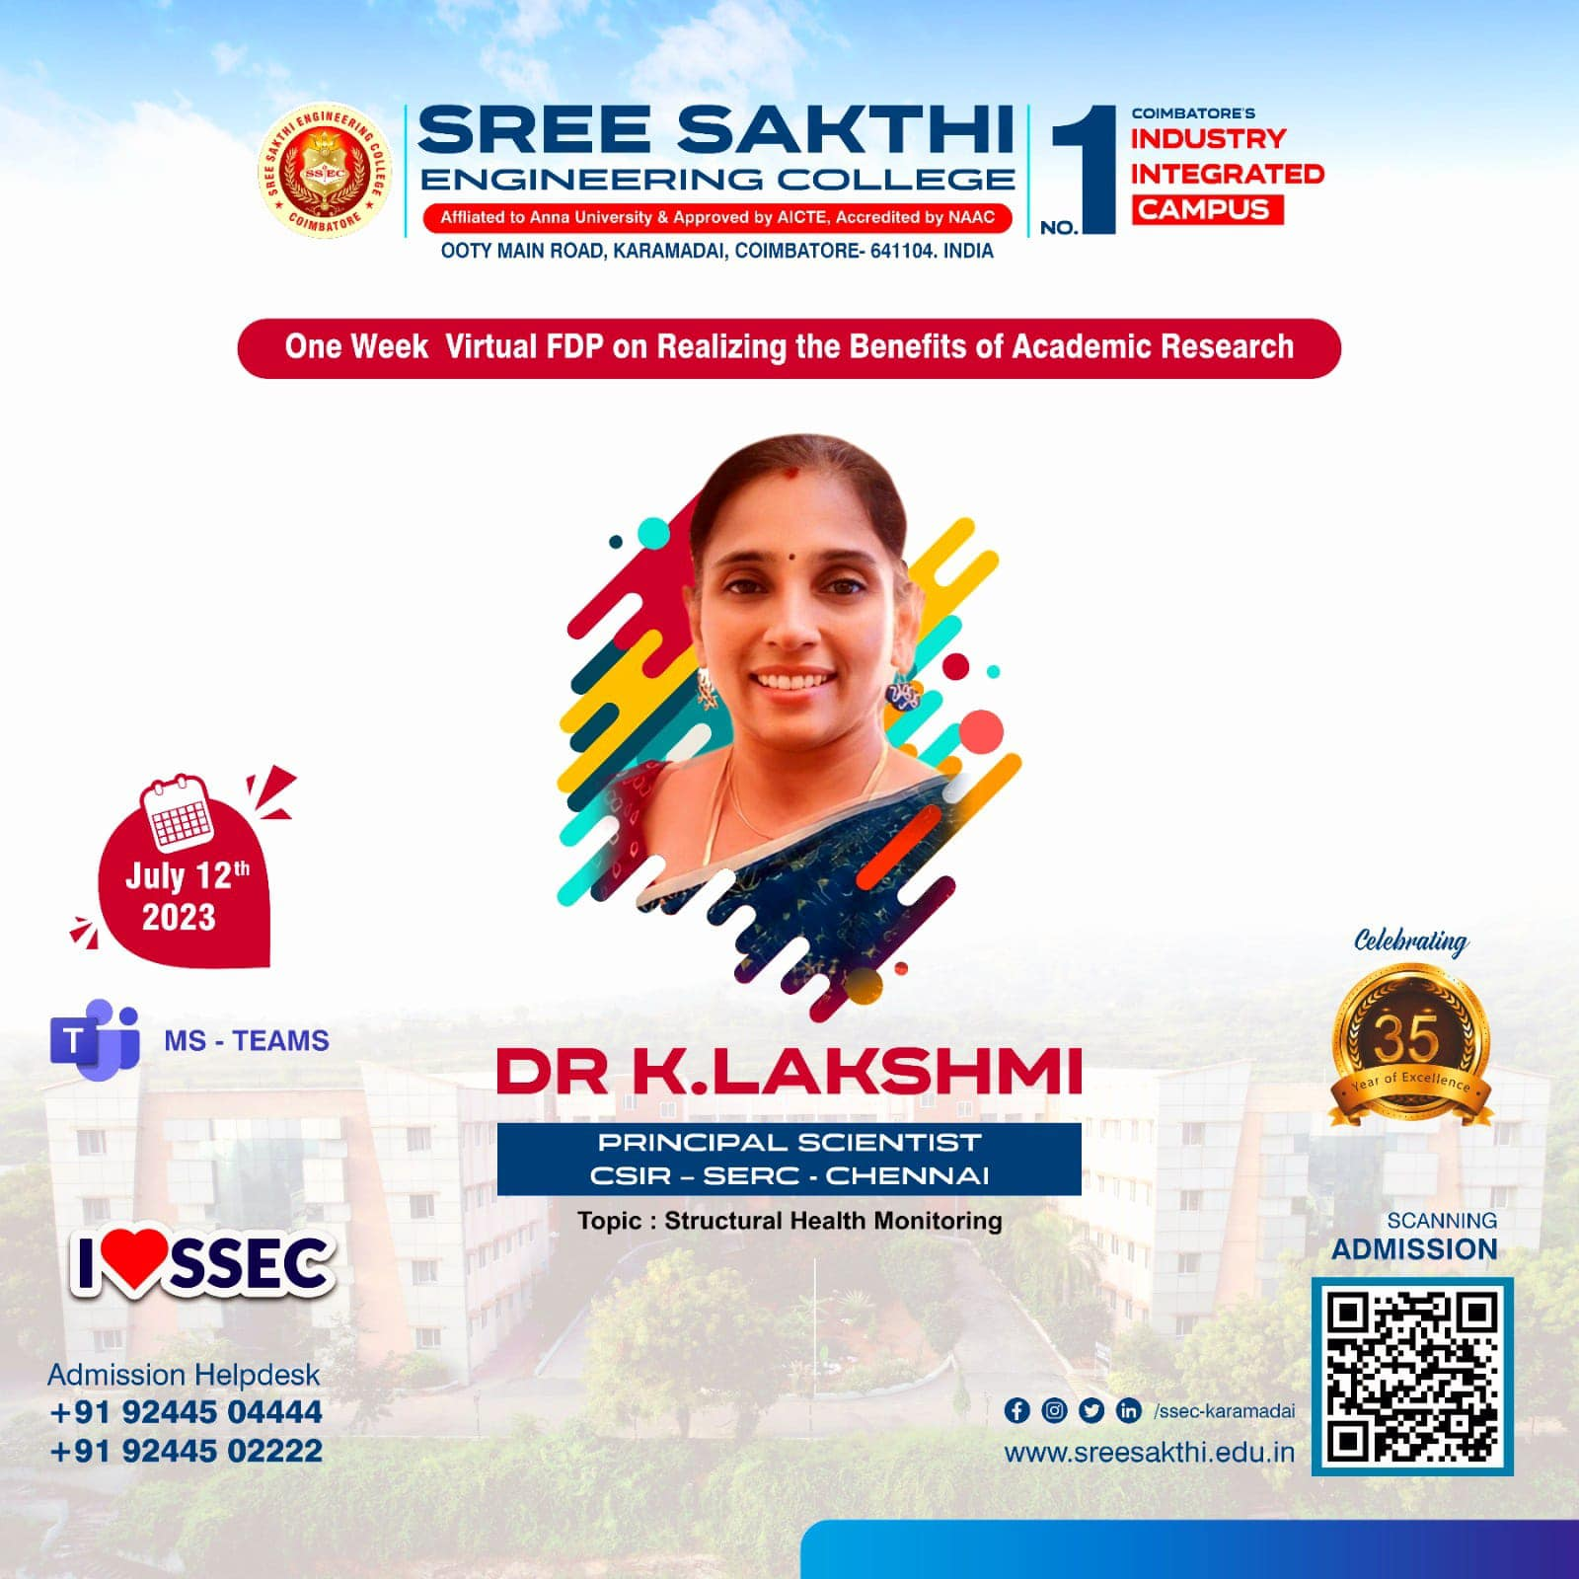
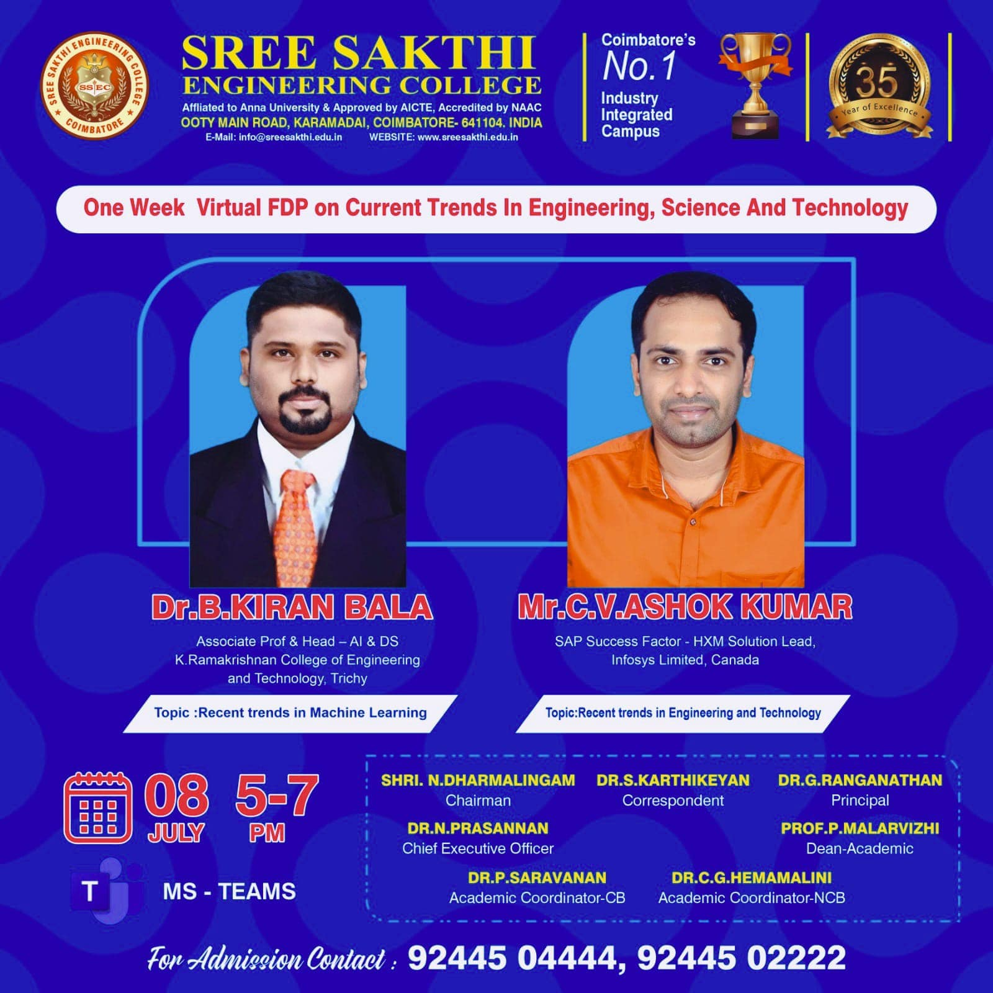
08/07/2023-one week virtual fdp on current trends in engineering science and technology
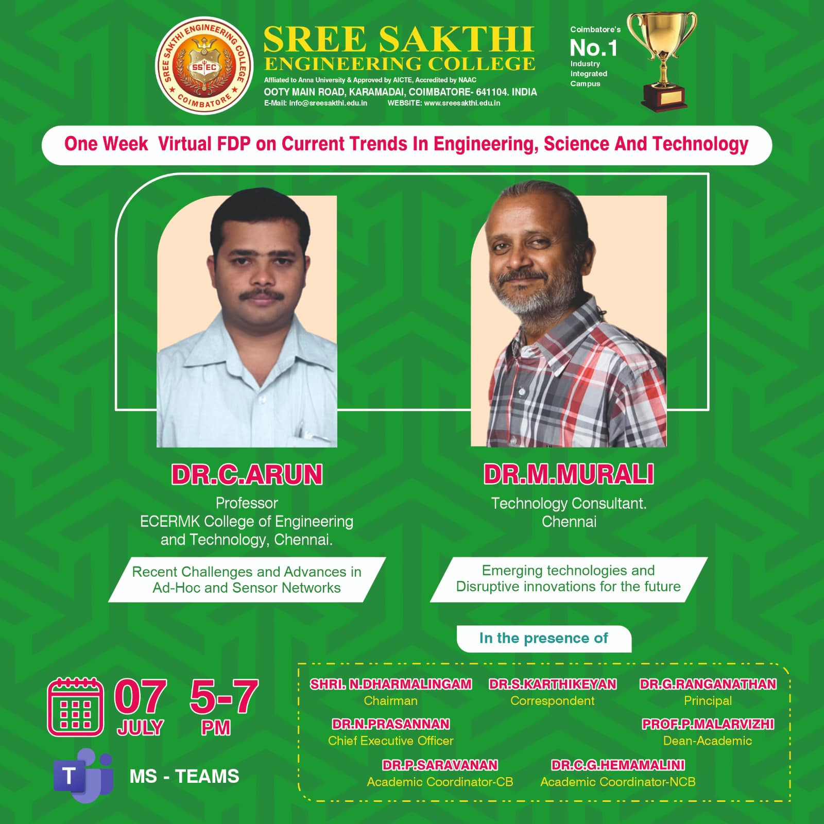
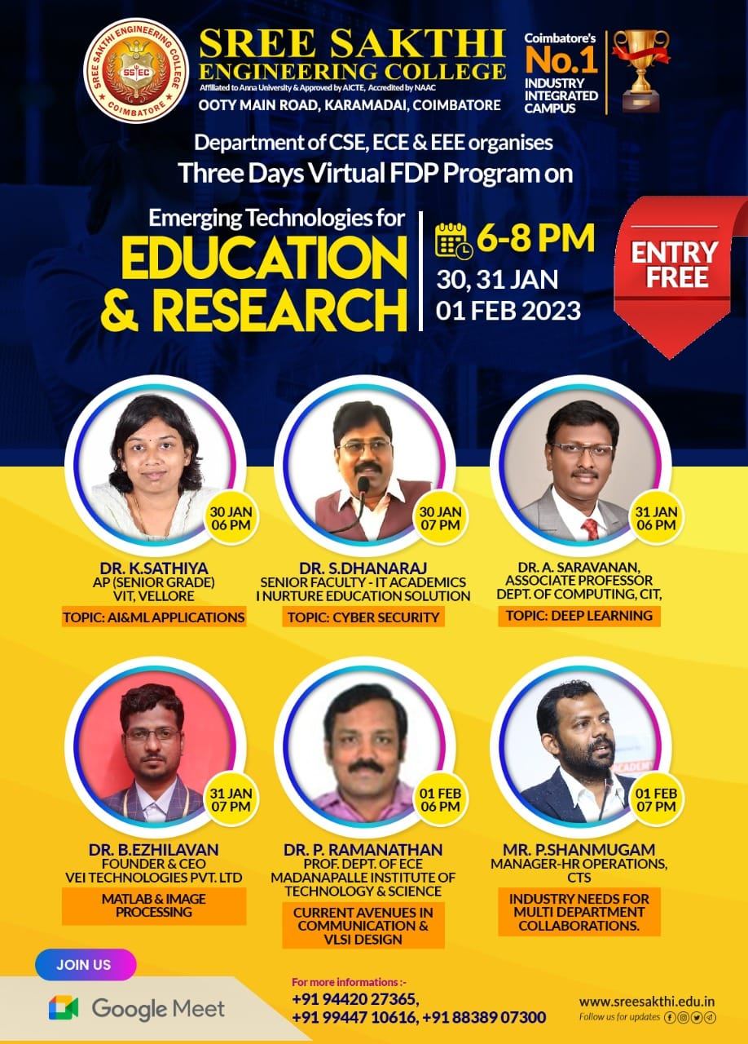
30/01/2023 and 31/01/2023-three days virtual fdp programs –emerging technologies for educations and reaches

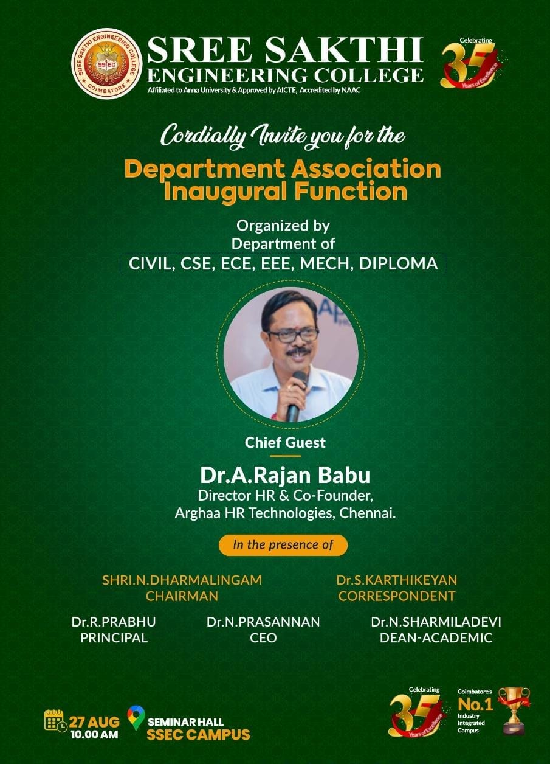
27/08/2022-departnment association inaugural functions

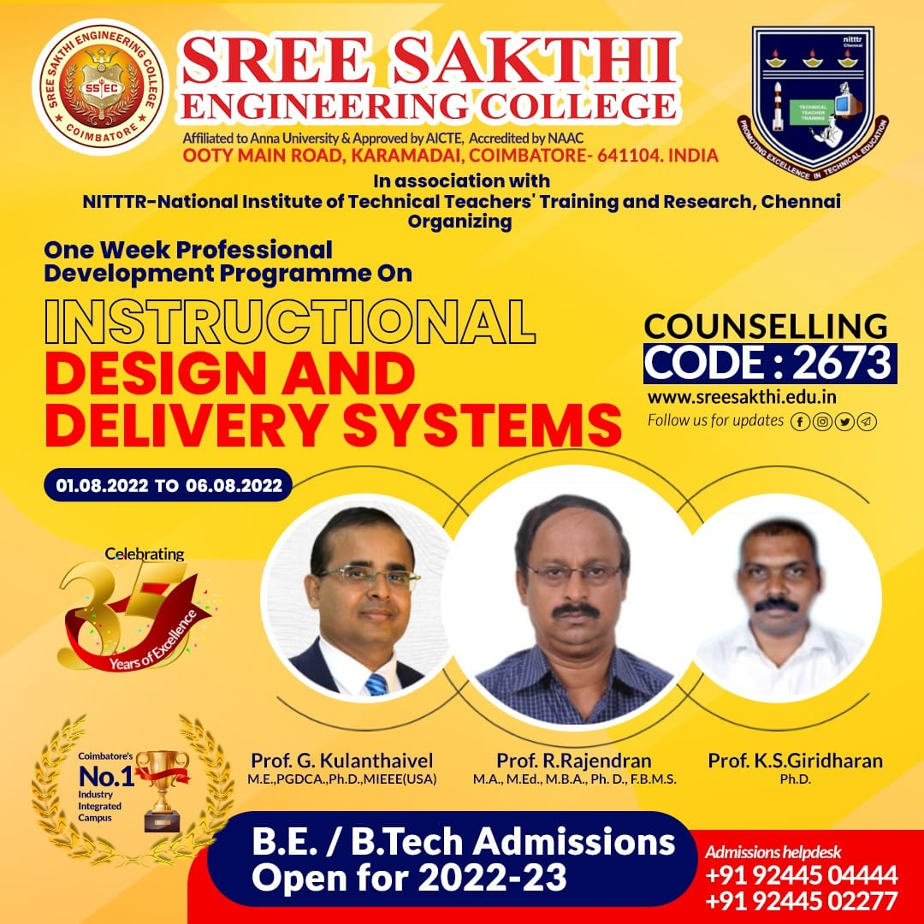
01-08-2023 to 06-08-2023-one weekfdp –design and delivery system
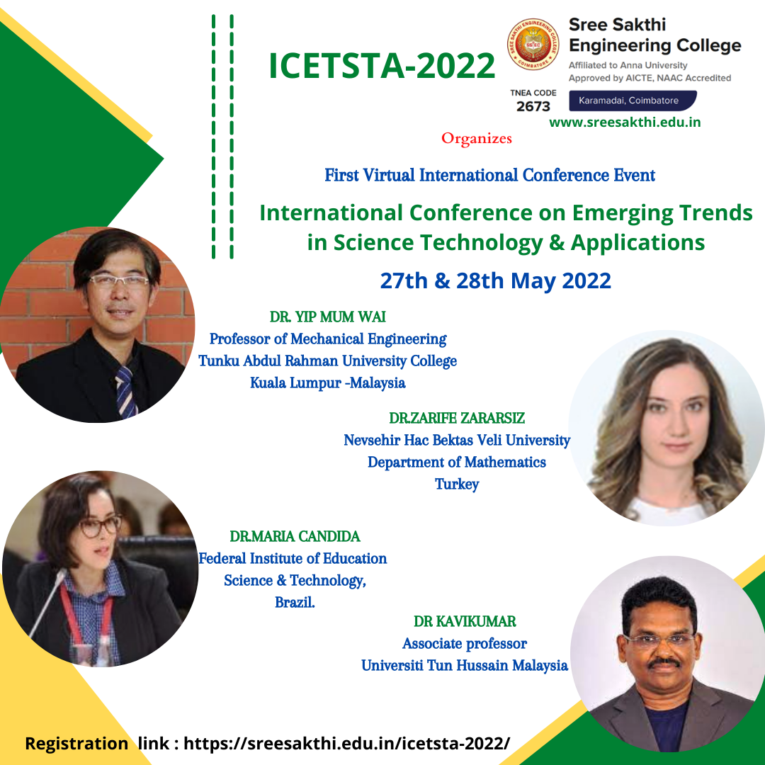
27/05/2023-28/05/2023-first virtual international conference international conference on emerging trends in science technology and applications
01-08-2023 to 06-08-2023-one weekfdp –design and delivery system
27/08/2022-departnment association inaugural functions
30/01/2023 and 31/01/2023-three days virtual fdp programs –emerging technologies for educations and reaches
08/07/2023-one week virtual fdp on current trends in engineering science and technology
12/07/2023-one week virtual fdp on realizing the benefits of academic research
22/07/2023-webinar-carrer guidance and new technologies to learn
05/08/2023-association inauguration functions –
05/08/2023-guest lecturer-internet of things
05/08/2023-student associativity activity
31/08/2023-motivational program –engineering day
07-10-2023-national level workshop-ethical hacking and cyber security
26/11/2022-win your weakness-motivation program
03/12/2022-quiz state programme –motivation program

