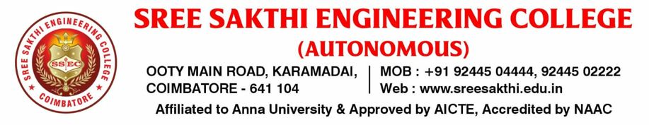
DEPARTMENT OF COMPUTINF TECHNOLOGIES
Center of Excellence – Center for OpenTech (ORACLE ACADEMY)
The Center for OpenTech, established as a Center of Excellence (CoE) under the Department of Computing Technologies, functions in collaboration with the ORACLE ACADEMY , a Government of India initiative under the National Mission on Education through ICT acdemy, Ministry of Education. This center is envisioned to focus on faculty development, skill-building, and innovation enables academic institutions to meet industry expectations and boost digital literacy.
Through their partnership, Oracle Academy provide:
- Faculty Development Programs to train teachers in advanced technologies
- Industry-Aligned Curriculum accessible to institutions at no cost
- Workshops and Webinars on emerging technologies like AI, machine learning, and cloud
- Student Certifications and Projects to enhance employability
- Access to Oracle Cloud and tools for real-world application development

Benefits to Students:
📌 Free Access to Industry-Grade Curriculum as students can learn Java, SQL, database
design, data science, AI, and cloud computing—skills highly valued in the job market.
📌 Hands-On Experience with Oracle Software and Cloud
📌 National-level certification as students can prepare for Oracle professional certifications, which enhance their resumes and improve job prospects in IT and related fields.
📌 Skill Development Workshops-Regular webinars, hackathons, and coding challenges help
students sharpen their technical and problem-solving skills.
📌 Career Readiness and Employability
📌 Cost-effective learning as all tools are freely available – promoting inclusive education.
The Center plays a pivotal role in bridging the gap between academia and industry in tech education. It supports students in academic projects, internships, hackathons, start-up ideation, and more. Additionally, it prepares students for the digital workforce by working together, Oracle Academy and ICT Academy are helping build a skilled, future-ready talent pool for India and beyond.
📍 For further details:
Faculty Coordinator – ORACLE ACADEMY
Ms. R. Pavithra, Department of Computer Science and Engineering
Sree Sakthi Engineering College
📧 Email: pavithra.cse@sreesakthi.edu.in | 📞 Phone: [7401027322]

