IIT BOMBAY – SPOKEN TUTORIAL

The Spoken Tutorial Project by IIT Bombay is a flagship e-learning initiative funded by the Ministry of Education, Government of India, under the National Mission on Education through ICT (NMEICT). It provides high-quality, self-paced, audio-video tutorials that help learners gain practical proficiency in Free and Open Source Software (FOSS) and a range of essential digital skills.
At Sree Sakthi Engineering College (SSEC), the Spoken Tutorial initiative has been integrated to enhance digital literacy and promote hands-on learning among students. The program offers tutorials across diverse domains including Programming (C, C++, Java, Python, PHP, Ruby), Web Development, Databases (MySQL, PostgreSQL), Scientific Computing (R, Scilab, Octave), Office Tools (LibreOffice, LaTeX), Graphics and Animation (GIMP, Blender), and System Administration (Linux, Ubuntu).
Following a “Learn by Yourself” approach, students can pause, practice, and progress at their own pace, ensuring active engagement and deeper understanding. Institutions can further organize online training sessions and certification tests, with successful candidates earning nationally recognized certificates from IIT Bombay.
This collaboration aligns with national missions such as Digital India, Skill India, and Atmanirbhar Bharat, by offering affordable, accessible, and high-impact digital education. Through this initiative, SSEC empowers students with industry-relevant technical skills, enhances employability, and fosters a culture of lifelong learning.
Key Highlights at SSEC:
- Hands-on training through FOSS-based learning.
- Multilingual tutorial support for inclusive learning.
- Self-paced and practical learning modules.
- IIT Bombay certification with national recognition.
- Strengthened academic and professional competencies.
- Supports academic learning, research, and career development.

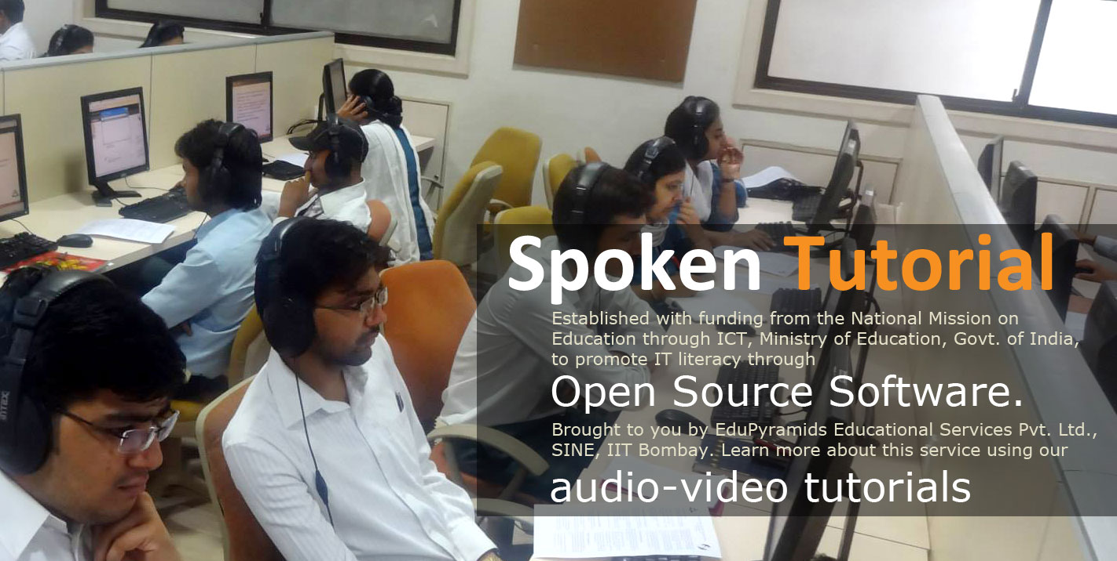

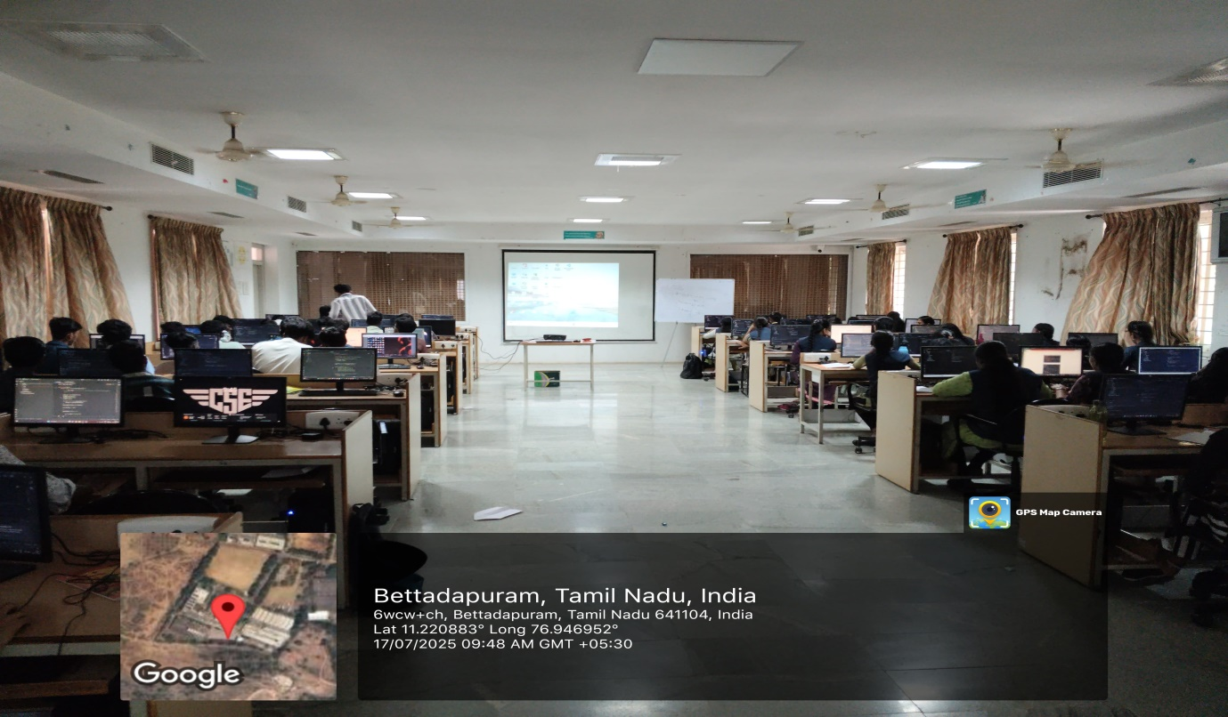

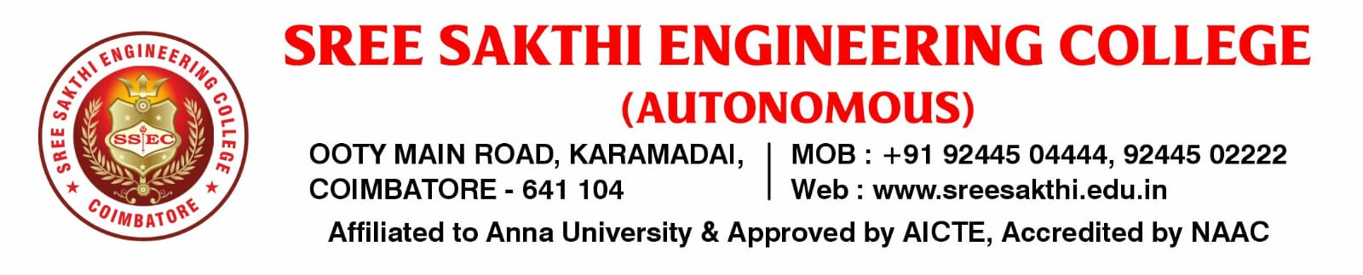
ACADEMIC YEAR (2024-2025) EVEN SEMESTER
IIT BOMBAY – SPOKEN TUTORIAL COURSE LIST
S.No |  | Semester Start Date | Software Course | Department | SEM/YR | Batch | Participant List Status
 |  | Jan. 20, 2025 | Linux | Artificial Intelligence and Machine Learning | IV/II | 2023-2027 | 32
 |  | Jan. 20, 2025 | PHP and MySQL | Artificial Intelligence and Machine Learning | IV/II | 2023-2027 | 32
 |  | Jan. 20, 2025 | Linux | Computer Engineering with Cyber Security | IV/II | 2023-2027 | 32
 |  | Jan. 20, 2025 | PHP and MySQL | Computer Engineering with Cyber Security | IV/II | 2023-2027 | 32
 |  | Jan. 20, 2025 | C and Cpp | BE CSE | IV/II | 2023-2027 | 64
 |  | Jan. 20, 2025 | Python - Python 3.4.3 | BE CSE | IV/II | 2023-2027 | 64
 |  | Jan. 20, 2025 | C and Cpp | Information Technology | IV/II | 2023-2027 | 61
 |  | Jan. 20, 2025 | Python - Python 3.4.3 | Information Technology | IV/II | 2023-2027 | 61
 |  | Jan. 20, 2025 | Blender | Computer Science and Engineering | VI / III | 2022-2026 | 62
 |  | Jan. 20, 2025 | PHP and MySQL | Computer Science and Engineering | VI / III | 2022-2026 | 62
 |  | Jan. 20, 2025 | C and Cpp | Electronics and Communication Engineering | IV/II | 2023-2027 | 22
 |  | Jan. 20, 2025 | C and Cpp | Electronics and Communication Engineering | VI / III | 2022-2026 | 31
 |  | Jan. 20, 2025 | Arduino | Electrical and Electronics Engineering (EEE) | IV/II | 2023-2027 | 27
 |  | Jan. 20, 2025 | Python - Python 3.4.3 | Electrical and Electronics Engineering (EEE) | VI / III | 2022-2026 | 14
 |  | Jan. 20, 2025 | Python - Python 3.4.3 | Mechanical Engineering | IV/II | 2023-2027 | 37
 |  | Jan. 20, 2025 | QCad | Mechanical Engineering | VI / III | 2022-2026 | 23
 |  | Jan. 20, 2025 | GIS - QGIS | Civil Engineering | VI / III | 2022-2026 | 6
 |  | Jan. 20, 2025 | GIS - QGIS | Civil Engineering | IV/II | 2023-2027 | 5
 |  | Jan. 20, 2025 | C and Cpp | Computer Science Engineering (CSE) | II/I | 2024-2028 | 44
 |  | Jan. 20, 2025 | C and Cpp | Computer Science and Engineering | II/I | 2024-2028 | 48
 |  | Jan. 20, 2025 | C and Cpp | Information Technology | II/I | 2024-2028 | 63
 |  | Jan. 20, 2025 | C and Cpp | Computer Science Engineering (AML) - Artificial Intelligence and Machine Learning | II/I | 2024-2028 | 62
 |  | Jan. 20, 2025 | C and Cpp | Computer Science Engineering (DS) - Data Science | II/I | 2024-2028 | 61
 |  | Jan. 20, 2025 | C and Cpp | Computer Science Engineering (Cyber Security) | II/I | 2024-2028 | 63
 |  | Jan. 20, 2025 | C and Cpp | Electronics and Communication Engineering | II/I | 2024-2028 | 10
 |  | Jan. 20, 2025 | Python - Python 3.4.3 | Electrical and Electronics Engineering (EEE) | II/I | 2024-2028 | 54
 |  | Jan. 20, 2025 | Python - Python 3.4.3 | Mechanical Engineering | II/I | 2024-2028 | 44
 |  | Jan. 20, 2025 | Python - Python 3.4.3 | Electronics and Communication Engineering | II/I | 2024-2028 | 57
 |  | Jan. 20, 2025 | Python - Python 3.4.3 | Civil Engineering | II/I | 2024-2028 | 25
 |  | Jan. 20, 2025 | Python - Python 3.4.3 | Civil Engineering | II/I | 2024-2028 | 35

